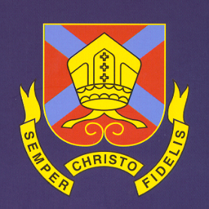
THE BISHOP OF HEREFORD’S BLUECOAT SCHOOL
Hampton Dene Road, Tupsley, Hereford HR1 1UU
Tel: 01432 347500
Enquiries: head@bhbs.hereford.sch.uk

Autumn 2024

Dear Parents/Carers

Reporting for Year 7 Students

This letter is to inform you how your child’s progress will be reported this year. There will be three reports sent home to you:-

A settling in report will be issued late in the Autumn term, reports are then issued in March and in July.

At Key Stage Three (year 7,8 and 9) we believe that it is important that students develop the right attitude to learning.

Contact can be made with teachers via e mail at any point in time if you have any concerns about your child. E mail addresses can be found at The Bishop of Hereford's Bluecoat School - Teaching Staff Emails (bhbs.hereford.sch.uk)

In the report we will be giving information to you about classroom learning behaviours, the quality of their classwork and their independent learning. Form Tutors will also comment on attendance, sessions late, rewards and consequences.

Students are assessed throughout the year in a variety of ways. There is ongoing formative assessment in every classroom. Examples include things like questioning, live marking of books, quizzing, mini whiteboards in lessons, in class questions and work, mini tests, feedback in books and so on. However, students also complete in class summative assessments at the ends of larger units of work. Students will be asked to revise and prepare for these larger assessments. Reports home will contain a summative assessment score as a percentage at Key Stage three.

Student books will detail their percentage test scores, and class average test scores. This is where students will also record their subject specific targets which are areas that they still need to improve following the assessments. This helps students to know what they have not yet learnt and therefore need to improve on. We encourage parents/carers to look at student books and to talk this through with students. We also encourage parents/carers to talk with your child about their revision preparation for these tests. They are shown how to prepare in class with things like flash cards, past questions and mind maps. You are encouraged to quiz them before the assessments on work they have been doing. Students should be aiming to get the best test scores that they can.

We also detail on school reports at key stage three how students are getting on with their reading. The accelerated reader score comes from test scores which students complete in our school library on books that they have read.

Further detail can be found on our website http://www.bhbs.hereford.sch.uk/Curriculum-Overview about what students study in each subject.

Parents’/Carers’ Consultation Evening is on Thursday 16th January 2025. Please place this in your diary, further detail will follow about how to make online appointments for this evening.

Yours sincerely,

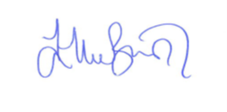

Ellie Bunston

Deputy Headteacher

