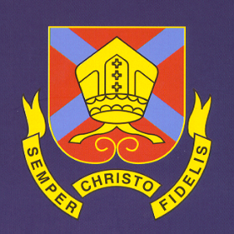
THE BISHOP OF HEREFORD’S BLUECOAT SCHOOL
Hampton Dene Road, Tupsley, Hereford HR1 1UU
Tel: 01432 347500
Enquiries: head@bhbs.hereford.sch.uk

Autumn 2024

Dear Parents/Carers

Reporting for Year 8 Students

This letter is to inform you how your child’s progress will be reported this year. There will be three reports:-

Reports will be issued late in the Autumn term, April and at the end of July.

Behaviours for Learning are reported which are explained fully on the report and on our website. Form Tutors will also comment on attendance, sessions late, rewards and consequences.

Further detail can be found on our website http://www.bhbs.hereford.sch.uk/Curriculum-Overview about what students study in each subject and areas for them to develop can be found at the front of student books.

Parents’/Carers’ Consultation Evening is on Thursday 15th May 2025. Please place this in your diary, further detail will follow about how to make online appointments for this evening.

Yours sincerely,

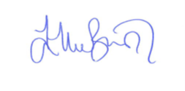

Ellie Bunston

Deputy Headteacher

