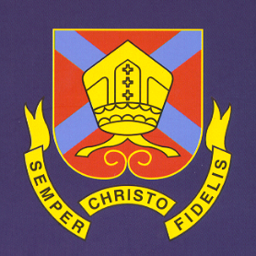
THE BISHOP OF HEREFORD’S BLUECOAT SCHOOL
Hampton Dene Road, Tupsley, Hereford HR1 1UU
Tel: 01432 347500
Enquiries: head@bhbs.hereford.sch.uk

Autumn 2024

Dear Parents/Carers

Reporting for Year 10 Students

This letter is to inform you how your child’s progress will be reported this year. There will be three reports:-

Reports will be issued late in the Autumn term, March and May. At the end of year 10 mock grades will be sent home based on exams sat in June.

Subject teachers will give a working at grade based on student progress towards their targets. Later in the year predicted grades will be given to indicate likely GCSE outcomes.

Students have an end of year Expected Progress Target (EPT). We generate this by doing baseline testing and using national data to link this to GCSE grading 1-9 (or Entry Level if a student is working below Grade 1). This information gives us a GCSE target grade.

Behaviours for Learning are also reported which are explained fully on the report and on our website. These have changed from last year and are now based on classroom learning behaviours, quality of classwork and independent learning.

Form Tutors will also comment on attendance, sessions late, rewards and consequences.

Further detail can be found on our website http://www.bhbs.hereford.sch.uk/Curriculum-Overview about what students study in each subject.

Parents’/Carers’ Consultation Evening is on Thursday 1st May 2025. Please place this in your diary, further detail will follow about how to make online appointments for this evening. There is also an important evening in school about how to support your child with their GCSEs on Thursday 3rd October 2024. Please do save the date.

Yours sincerely,

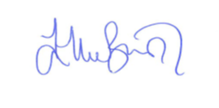

Ellie Bunston

Deputy Headteacher

