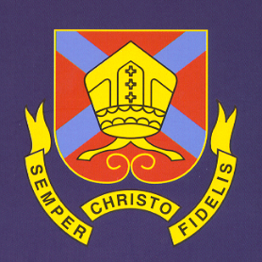
THE BISHOP OF HEREFORD’S BLUECOAT SCHOOL
Hampton Dene Road, Tupsley, Hereford HR1 1UU
Tel: 01432 347500
Enquiries: head@bhbs.hereford.sch.uk

Autumn 2024

Dear Parents/Carers

Reporting for Year 11 Students

This letter is to inform you how your child’s progress will be reported this year.

Reports will be issued in November and another set is issued in February.

Subject teachers will give a working at grade based on student progress towards their targets and predicted grades where appropriate.

Students have an end of year target grade. We generate this by doing baseline testing and using national data to link this to GCSE grading 1-9 (or Entry Level if a student is working below Grade 1).

Behaviours for Learning are also reported which are explained fully on the report and on our website. These have changed from last year and are now based on classroom learning behaviours, quality of classwork and independent learning.

Form Tutors will also comment on attendance, sessions late, rewards and consequences.

Mock examinations will take place in November and again in February. Please support your child in preparing for these important examinations. To help you and them to prepare there will be evenings in school around revision strategies and exam information. Please do keep these dates free to come into school at 5pm on Wednesday 25th September and Wednesday 20th November 2024.

Further detail can be found on our website http://www.bhbs.hereford.sch.uk/Curriculum-Overview about what students study in each subject.

Parents’/Carers’ Consultation Evening is on Thursday 30th January 2025. Please place this in your diary, further detail will follow about how to make online appointments for this evening.

Yours sincerely,

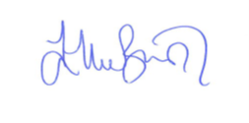

Ellie Bunston

Deputy Headteacher

