
LIVINGSTONE lOG

Thinking outside the box!

Hello from Livingstone House
We have gone technical: follow @BHBSLivingstone on Instagram! (Instagram is for ages 1 and over but a reminder for parents of students who are aged 11,12 and 13 it is probably a good idea to control the instagram access)
So, 7 weeks of lockdown and counting! I am still enjoying my runs and walks around Tupsley and the wider area. The Instagram is getting a good following and the 2:6 challenge is underway. Please try and donate if you can, and take part if you would like. All funds are going to St Michael’s hospice. Any updates to tell me about can be sent to robertsone@bhbs.hereford.sch.uk putting “Livingstone Log” in the subject bar along with your name and form. Thanks to those who have contributed.


it hurt to sit down in the evening after being bounced around driving over the field and we did not have the best weather to do it, which is typical of our timing!
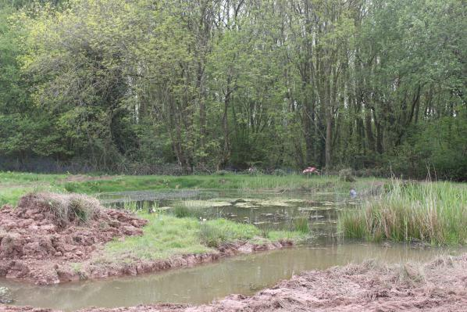I was also given the wonderful job of cleaning the pond…… not sure how it’s me that ends up doing this? However, five hours in the water and I looked like a shrivelled-up prune and on top of that I lost my wellies when I got stuck in the middle and the only way I could get un stuck was take my feet out of them! O well, I’m sure the newts and frogs will like them.
We also had a issue with a water leak…… strange how only a small person could fit down the hole to carry on digging down to find it. Also strange how I am apparently the small one in the family! It got really deep and my wonderful husband went off to do something else and left me stuck there. Funny enough when he went down, he found a ladder. Haha.
Well, with luck I will get to see you all soon. In the meantime, keep sending in your wonderful art work to us.
Keep safe, Mrs Gregory

Tutor Shout Outs
Mrs Gregory, tutor to LLV
Hi Everyone,
Hope you are all well. This whole lock down is not what I had imagined when starting my new job at Bishops. The first thing I would like to say is that the first half term has been brilliant and everyone has made me feel so welcome. I have had so much fun teaching art and meeting you all. Mr Haylock and I have lots of plans in store for when get back, so it’s going to be very exciting in Art!
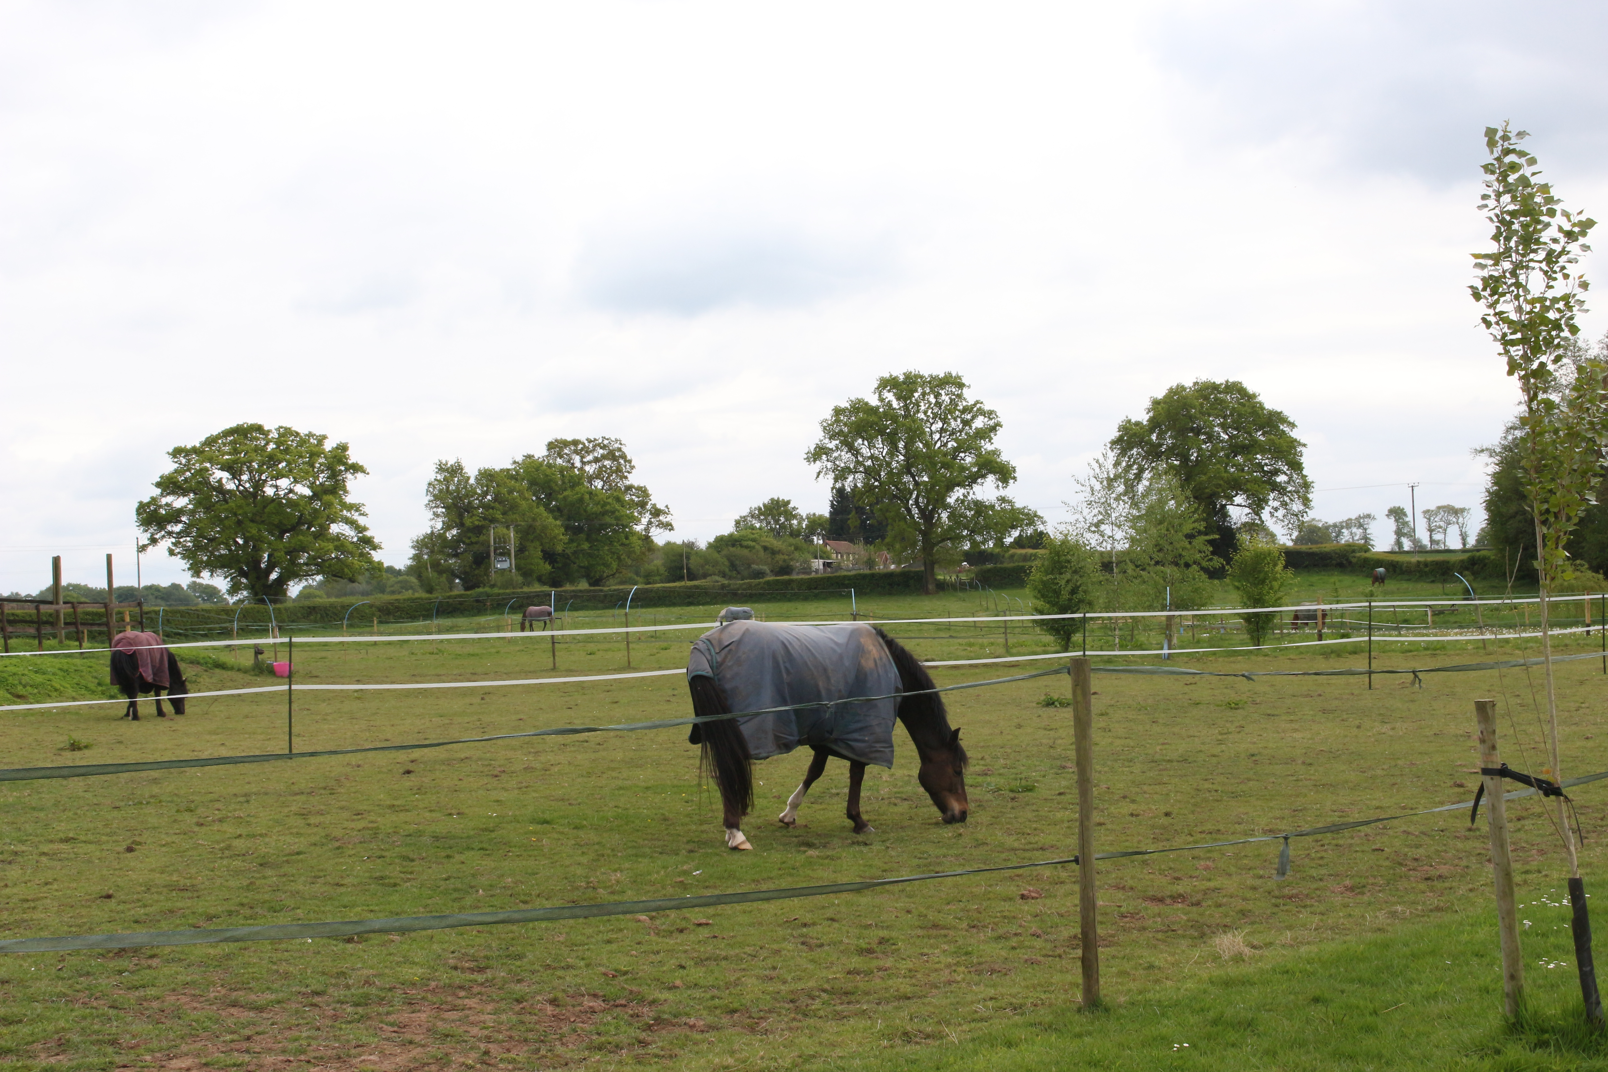So, what have I been up to apart from seeing all the brilliant art work being sent to me? Well, our horses have all had a holiday, enjoying the sun and the new grass coming through. We decided to extend our pound and put a small island on it, as we have some wild ducks visit us to nest each year and wanted to try and give them a safer place to nest on. I have to do lots of planting (which is not my thing as I hate gardening), but when done it should be nice. I had the delightful job of driving the dumper truck across the field, I must admit it hurt to sit down in the evening after being bounced around driving over the field and we did not have the best weather to do it, which is typical of our timing!
I was also given the wonderful job of cleaning the pond…… not sure how it’s me that ends up doing this? However, five hours in the water and I looked like a shrivelled-up prune and on top of that I lost my wellies when I got stuck in the middle and the only way I could get un stuck was take my feet out of them! O well, I’m sure the newts and frogs will like them.
We also had a issue with a water leak…… strange how only a small person could fit down the hole to carry on digging down to find it. Also strange how I am apparently the small one in the family! It got really deep and my wonderful husband went off to do something else and left me stuck there. Funny enough when he went down, he found a ladder. Haha.
Well, with luck I will get to see you all soon. In the meantime, keep sending in your wonderful art work to us.
Keep safe,
Mrs Gregory


This Friday is the 75th Anniversary of victory in Europe, following the 6 long, harrowing years of World War 2. With all the bombing, inhumanity, displacement, destruction and death, it must, at times, have felt like it would never end.
But, rather like our situation now, people endured and did what had to be done. Children were evacuated away from big cities and had to leave their families and homes behind.
Women were conscripted for the first time, taking up jobs like munitions and roles in the land army.
Families had to spend countless nights and days in shelters, sometimes losing their homes and possessions in the bombing raids.
Rationing was introduced and supplies got very difficult at times, with substitutions having to be found, or people just went without.
However, again, parallels with today can be drawn. That “Keep calm and carry on” spirit is still visible in Britain and the wider world today. The iconic image of the milk man in London walking over the rubble reminds me of all the front line and key workers that we are relying on at the minute.
So after all the hardships, its no wonder that Britain and part of Europe celebrated.
Eventually we will get through our current situation too, but like our Thursday clap to say thanks to the NHS and key workers, Friday 8th May is about saying thank you to those who gave so much during World War Two.

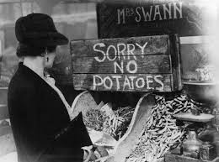

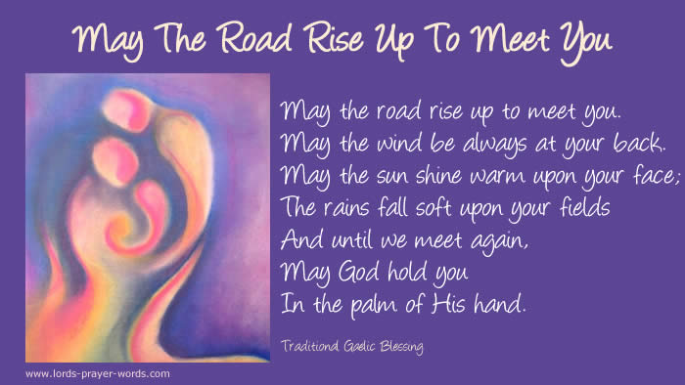
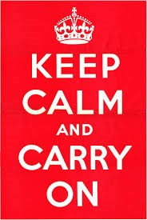

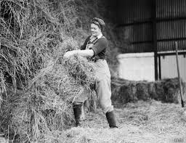
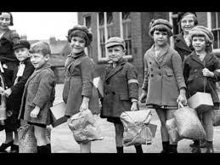
Below is one of my favourite prayers, or more of a blessing. I had it at my wedding when I was surrounded by my family and friends, who I can’t be close to at the moment; and like the words of Dame Vera Lynn, “We’ll meet again, don’t know where, don’t know when!” but this prayer reminds me to be thankful, and to have faith and hope.

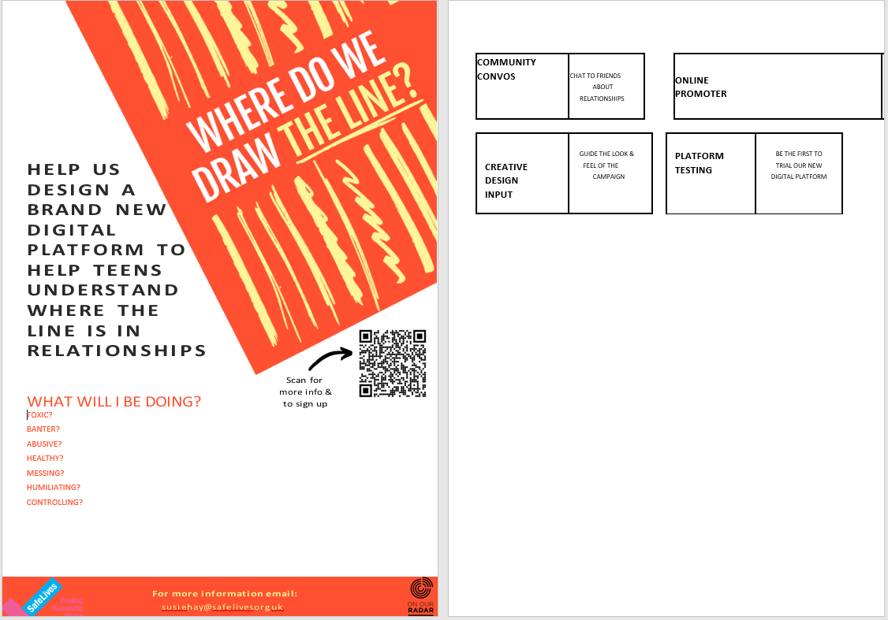
Friday Challenge
Baking time for the Friday Challenge this week. Hope you had an easier job of finding icing sugar than I did to make the 26 cup cakes!


Our School House challenge is up and running, so please remember to go to the JustGiving page for Livingstone House www.justgiving.com/fundraising/bhbs-livingstone-house where you can donate. I have had a couple of replies to which challenge to undertake so watch this space. We need to keep donating before the challenges can begin. Let’s show our support for St Michael’s hospice, just like we would if we were having a non-uniform day or a bake sale.
Thank you.

