

THE BISHOP OF HEREFORD’S BLUECOAT SCHOOL



Jesus said: “I have come that they may have life, life in all its fullness.” This teaching is at the heart of our school community. Through a culture of positive learning experiences rooted in core Christian values, our students will flourish and lead fulfilling lives.

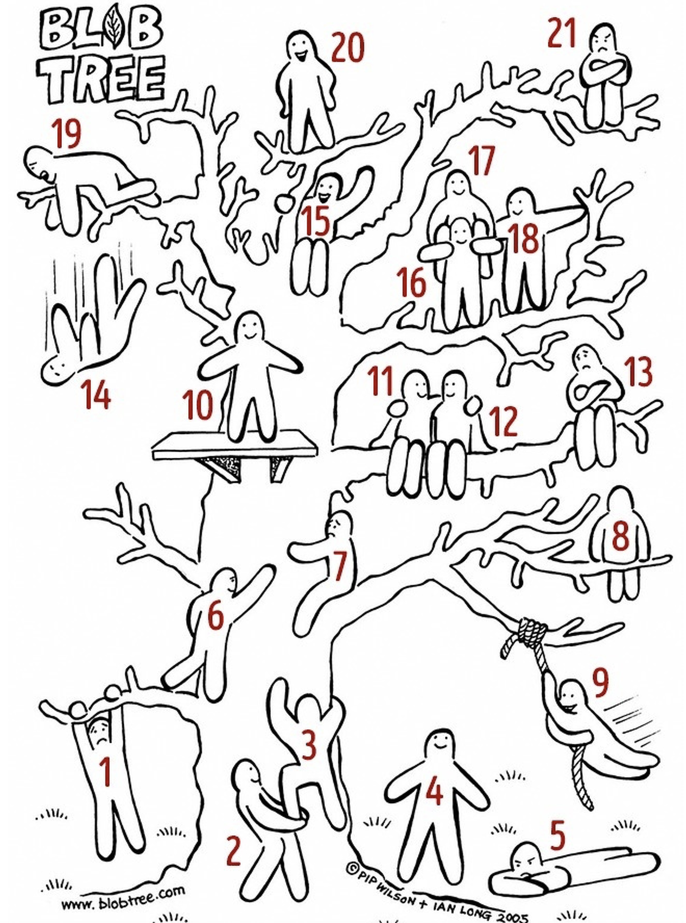

Which character are you at the moment?

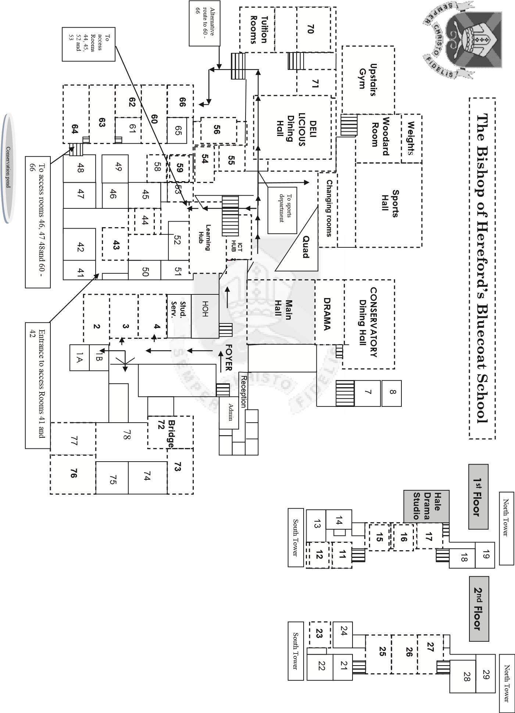

TIMES OF THE SCHOOL DAY

A bell will sound at 8.45am.
This is the movement bell which means you need to make your way to your Form room ready to be registered at 8.50am.

School Day | AM REG | P1 | Break | P2 | P3 | Lunch | P4 | Form Time | P5
Year 7 | 8.50 - 9.00 | 9.00 - 10.00 | 10.00 - 10.25 | 10.25 - 11.25 | 11.25 - 12.25 | 12.25 - 12.55 | 12.55 - 1.55 | 1.55 - 2.20 | 2.20 - 3.20

THE ORGANISATION OF THE SCHOOL

The school is led and managed by the Senior Leadership Team (SLT).

The Senior Leadership Team are:

Mr Williams - Headteacher
Mr Gibbins - Deputy Head
Mrs Bunston - Deputy Head
Mr Collingbourne - Assistant Head
Mr Nicholas - Assistant Head
Mrs Christopher - Business Manager
Mr Vaughan - SENCO

HOUSES

The school has four Houses. The Houses are called:

Ashley | Livingstone | Cheshire | Shaftesbury

Each House has a leader called the Head of House. They are:

House | Head of House
Ashley | Mrs Collingbourne
Livingstone | Mrs Robertson
Cheshire | Mrs Whittaker
Shaftesbury | Mr Atkinson

*** Your mentor is Mrs Lancaster ***

FORM GROUPS

The name of your Form Group has three letters. The first letter of your Form name will either be

A – if you are in Ashley House
L – if you are in Livingstone House
C – if you are in Cheshire House
S – if you are in Shaftesbury House

Each year group has 2 Forms in each House.
For example, in Year 7 there will be two Forms in Ashley, two Forms in Livingstone, two Forms in Cheshire and two Forms in Shaftesbury. This is the same for Years 8, 9, 10 and 11.

One form is known as ‘Left (L)’, the other is known as ‘Right (R)’

‘L’ or ‘R’ makes up the next letter of the form title

The third letter of your Form names tells us which year group you are in.

- Every September, the new Year 7 will be known by the next letter of the alphabet.
- Your year will be known as Year B.

COMPUTER ACCESS

You will need to be able to sign onto the BHBS computer system.
Your username will be

- your surname (in lowercase)
  - followed by your first initial (and second initial if you have one)

  - followed by the year you started Year 7

for example

- Jonesbj25

IF YOU ARE UNWELL

If you feel unwell during the day:

- Tell your teacher who will send you to the medical room. They may ask a friend to take you.

- The staff on duty in the Medical Room will look after you and decide if you need to go home or whether you should go back to your lesson

IF YOU HAVE AN APPOINTMENT AND NEED TO LEAVE SCHOOL

If you have an appointment during the day, for example the dentist, you must:

- Ask your parents to contact us via the student absence form on the website

- The attendance officer will then code the register so that your teacher will know you will need to leave school.

- Remind your teacher at the start of the lesson and then ask to leave when it’s time to go.

- You will then need to report to Student Services to collect a slip which will give you permission to leave school via Main Reception.

If there is a fire or fire drill:

- A continuous bell will sound.
- Walk quietly and calmly through the nearest exit to the tennis courts.
- Line up with your Form Group
- Your Form Tutor will take a register
- You must stand in silence until you are told to go back to your lesson.
- When you are dismissed, walk quietly and calmly back to your lesson.

A fire alarm check takes place every Friday at 12pm.

A continuous bell will sound.

This is a test only. You do not need to evacuate.

CHECKLIST

What is your Form Group called?

What is the name of your Form Tutor?

What is the name of your Head of House?

What is the name of your Pastoral Mentor?

What is the name of our Headteacher?

What time does school start?

What are the rules about the use of mobile phones?

Where do you go if there is a fire alarm?

What day and date do we start?

What should you do if you feel unwell?

How will you travel to and from school?

