+
The Bishop of Hereford’s
Bluecoat School

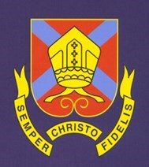

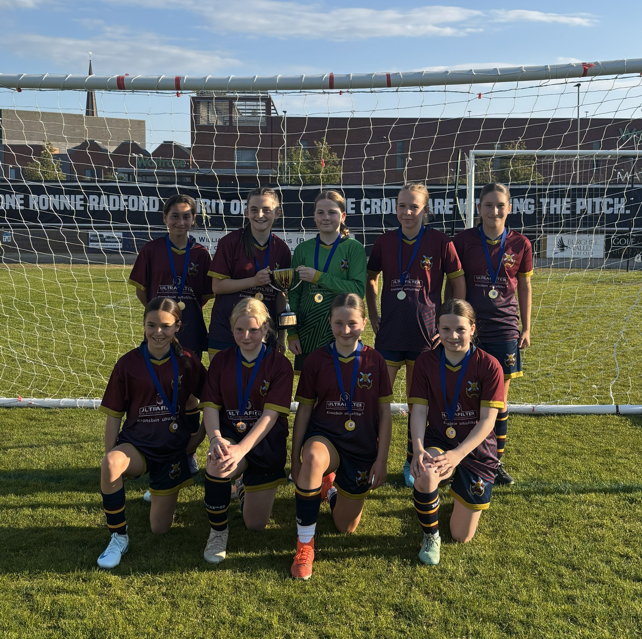
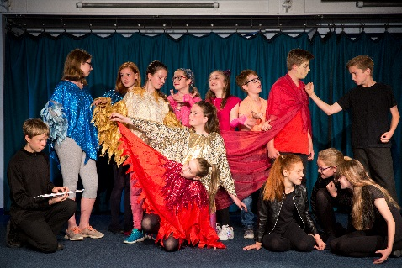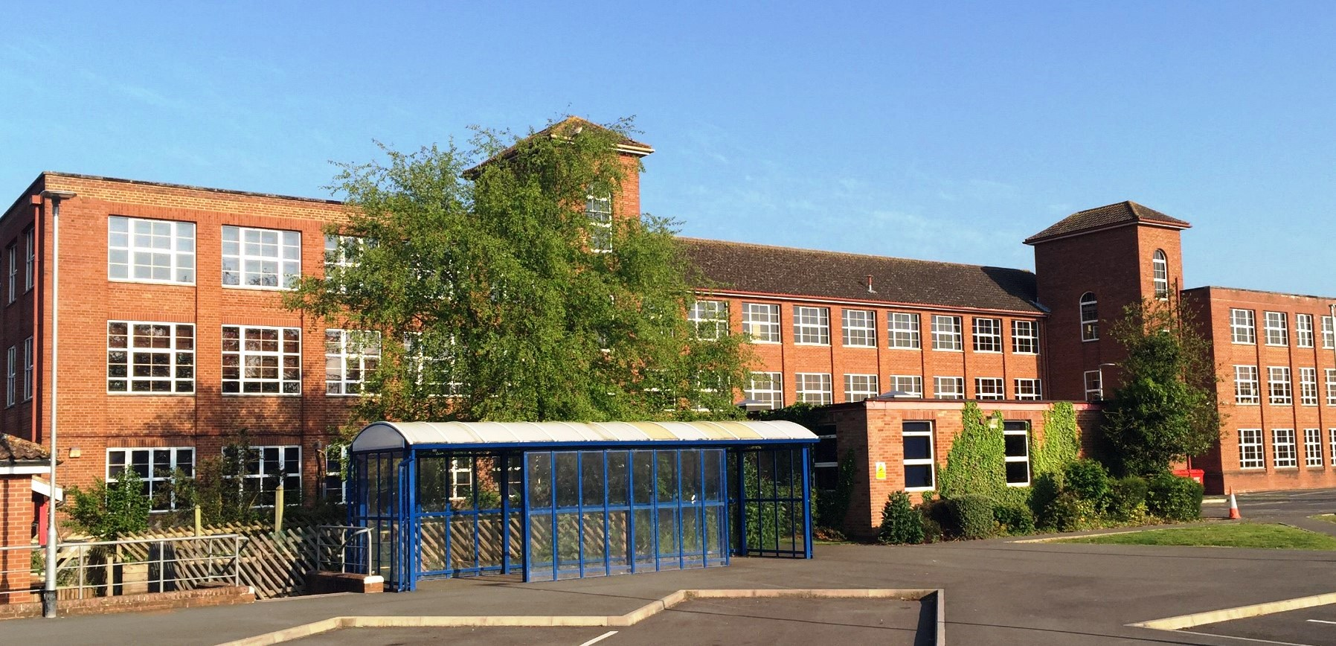

“Life in all its fullness”

- Welcome from the Headteacher
- Introduction
- Your Choices
- GCSE Art, Craft and Design
- GCSE Computer Science
- GCSE Combined Science
- GCSE Design and Technology: Graphical Communication
- GCSE Design and Technology: Manufacturing Materials
- GCSE Design and Technology: Product Design
- GCSE Drama
- GCSE English Language
- GCSE English Literature
- GCSE Food Preparation and Nutrition
- GCSE Modern Languages (French)
- GCSE Geography
- GCSE Modern Languages (German)
- GCSE History
- GCSE Mathematics
- GCSE Music
- GCSE Physical Education
- GCSE Religious Studies
Year 10 Options
Key Stage 4: (2026 – 2028)

- GCSE Modern Languages (Spanish)
- GCSE Triple Science
- Hospitality and Catering
- Creative & Media
- Pathways Form
- Careers Education, Information and Guidance
- Some questions to think about?

- Welcome from the Headteacher
- Introduction and Your Choices
- GCSE Art, Craft and Design
- GCSE Business
- GCSE Computer Science
- GCSE Combined Science
- GCSE Design and Technology
- Performing Arts Technical Award (GCSE equivalent)
- GCSE English Language
- GCSE English Literature
- GCSE Food Preparation and Nutrition
- GCSE Languages (French)
- GCSE Geography
- GCSE History
- GCSE Mathematics
- GCSE Music
- GCSE PE / CNAT Sports Studies (GCSE equivalent)
- GCSE Religious Studies
- GCSE Languages (Spanish)
- GCSE Triple Science
- Cambridge National in Creative iMedia (GCSE equivalent)
- CNAT Health and Social Care Technical Award (GCSE equivalent)
- ASDAN and Springboard overview (INVITE ONLY)
- Options Guidance
- Careers Education, Information and Guidance
- Important Dates and Your Notes

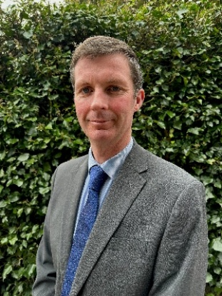
Welcome to Options Evening

Dear Parent/Carer and Student,
This is an exciting time to be a Year 9 student at Bishop’s, they will soon be choosing some of the subjects to study for the next two years. This is the first opportunity in a student’s school career that they get to have real control and choice over their studies. These choices will become approximately 40% of timetabled lessons from September 2026. The decisions that must be made are not always straightforward. Education is ever changing and there are many factors that will need to be considered. The options process takes account of the latest advice and what we feel is the best provision for our students.
At Key Stage 4 a student timetable will be made up of a common core of subjects which are compulsory, and several others that students will choose. The common core subjects are:
English Language English Literature Mathematics Physical Education Religious Studies (Short) Science (Combined or Separate)
You will also study Skills for Life through your subjects, form time sessions and special collapsed sessions during the year.
We want students to follow a broad and balanced curriculum in Years 10 and 11 as we believe that this is important for their future success and will provide a solid platform for them to continue their education beyond Bishop’s. At the same time, the government is keen for most students to study at least eight subjects to GCSE (or equivalent). Most students will actually study at least nine subjects to GCSE (or equivalent) level.
We have included as much choice as possible in the range of courses available to students. Students will leave school with an Attainment 8 score (reflecting the grades they receive across their subjects) and a Progress 8 score (reflecting the amount of progress that they have made in their subjects from their KS2 primary score). In these measures English and Maths carry an increased double weighted score. Maths and English are therefore crucially important.
Please reflect upon the English Baccalaureate (EBacc). This is a measure that recognises that a student’s outcomes comprise GCSEs at grade 5 and above in English, Maths, Combined Science (or Separate), History or Geography and a Language. We strongly encourage students considering certain A-Levels, career paths or University courses in the future to consider this combination but feel it is better to allow families to make this choice, whilst being fully informed of its significance with advice from tutors and senior leaders in school.
Academic achievement is not the only area by which students are judged. Throughout their school career students are encouraged to learn and develop skills which will be of value to in adult life. These include speaking and listening skills; the ability to research; making decisions based on well informed facts; being independent as a learner and developing group-working skills.
All students will have an opportunity to talk through their final options choices with a member of school staff, further information is also available on our web site. Mr Collingbourne (Assistant Headteacher) is leading our work on options; he is an expert source of information for students. Students should also seek advice from their subject teachers and/or subject leaders, along with Mrs Williams our Careers Consultant. Their Form Tutors and Heads of House are also available if necessary.
Good luck to all our students over the next few weeks as they think about their choices. Students, talk to as many people as you can and ask as many questions as you can. Choosing the right subjects will help you to be as successful as possible in your last two years here at Bishop’s.

T Williams
Headteacher

Introduction
This booklet is to help students make sure that they study the right courses for their abilities, needs and interests. Selecting the right course is important and it could affect their future.

Who Chooses?
Every student will have an interview with a teacher in April to help select the right courses.
Students, parents/carers, and teachers all play an important part in deciding on the best course combination.
Once subjects have been chosen, if teachers feel the subjects that have been chosen are not the best ones, we will discuss them with students and with parents/carers. We will not make changes without discussing them with students and with parents/carers again.
We shall do our very best to allocate students to their preferred courses. This will be a fair process.
Please note however, that some courses may be oversubscribed so we cannot guarantee students choices. In the event of an option not having a large enough take up, it will not run.

Supportive Options Pathway Guidance – 3 Groups
Each student has been assigned to a specific options pathway, and this has been designed to ensure that each student receives the correct guidance, to ensure they select GCSE courses that maximises their future potential. This is guidance, not compulsory.

Group B - Based on the academic profile of your child, we would strongly recommend they consider opting for the some or all the following subjects.
Triple Science, French, Spanish (if studied in KS3) and Computing.

Group HB - Based on the academic profile of your child, we would advise they only opt for the subjects below if they have a significant passion for these subjects and their teacher supports the request.
Triple Science and Computing.

Group S - Based on the academic profile of your child, they can opt for the ASDAN and / or the Springboard pathway resulting in them doing one or two less GCSEs. Based on an induvial basis, these students will study some or all the following courses.
ASDAN, Arts Awards, Entry Level qualification and Springboard.

Curriculum summary –

All students will study core subjects of English Literature, English Language,
Mathematics, Combined Science, Religious Studies (short course) and Core PE. Option subjects make up the remaining hours per fortnight.
Provision is also made for careers education and guidance.
Our curriculum delivers Spiritual, Moral, Social and Cultural (SMSC) Education through our varied assembly programme, through all subjects and through Religious Studies.
Our curriculum also includes high quality extra-curricular opportunities on which we place high value. Students can develop through sport, arts, drama, music and trips, to enrich their educational experience at our school.

GCSE Art, Craft and Design
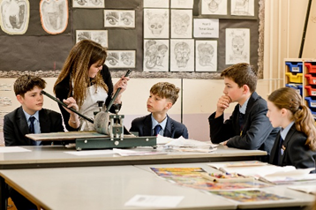
Why will I enjoy Art, Craft and Design?
You will be encouraged to discover, then develop your own strengths and interests in the subject and, increasingly, follow your own lines of enquiry.

What abilities may help me in Art, Craft and Design?
- Good drawing ability.
- Confidence in taking creative risks and learning from experience.
- Self-motivated with an ability to sustain focus for a lengthy period and full engagement with homework.

What will I learn in Art, Craft and Design?
You will be encouraged to engage in the creative process of Art, Craft and Design in order to develop as an effective and independent learner, and as a critical and reflective thinker with an enquiring mind. You will acquire and develop technical skills through working with a broad range of media, materials, techniques, processes and technologies.

How will I get marks in Art, Craft and Design?
Work is assessed according to four assessment objectives and are equally weighted:

AO1: Developing ideas through investigations, demonstrating critical understanding.
AO2: Refining work by exploring ideas, selecting and experimenting with appropriate media.
AO3: Recording ideas, observations and insights relevant to intentions as work progresses.
AO4: Presenting a personal and meaningful response that realises intentions and demonstrates understanding of visual language.

What is the structure of the course?
In Year 10, following a term of foundation skills practice, you will begin Component 1: Portfolio of Work (NEA, 60% weighting) where you will explore different Art forms within five possible areas, depending upon time and student commitment:

 | Fine Art: Drawing, Painting, Printmaking.
 | Graphic Communication: Advertising, Branding, Illustration.
 | Textile Design: Fashion Design, Printed/Dyed Textiles, Stitched/Embellished Textiles.
 | Three-dimensional Design: Sculpture, Ceramics, 3D Modelling.
 | Photography: Documentary Photography, Film and Video.

In the Autumn Term of Year 11, you will produce a final outcome for the topics explored through the different Art forms, building upon the skills learnt in Year 10. The Spring and Summer Term will be based upon Component 2: Externally Set Assignment (practical exam, 40% weighting).

If I take Art, Craft and Design what can I do with it as a career in the future?
The Creative Industries are the biggest employers in the UK. There is a lot more choice than you think.
Within Art, Craft and Design you can pursue careers as an Architect, Fashion/Clothing Designer,
Graphic Designer, Illustrator, Interior Designer, Packaging/Product Designer to name but a few. Within Media, Print and Publishing job opportunities that are open to you: Animator, Art Director, Broadcast Journalist, Creative Director, Games Designer, Photographer, Photojournalist, Publishing Editor, Website Designer, TV/Film Producer/Editor/Director. Within Information and Culture you can become an Art Teacher, Museum/Art Gallery Curator, Arts Administrator, Arts Technician. Within Manufacturing and Production you can follow a vocation as a Ceramic/Pottery Maker, Furniture Maker, Glassmaker, Lighting Designer, Textile Operative. These career opportunities are only a few of the vast jobs that a qualification in Art, Craft and Design can be useful in.

How can I find out more?
https://www.ocr.org.uk/qualifications/gcse/art-and-design-j170-j176-from-2016/specification-at-a-glance/

Curriculum Team Leader:
Mr H Sutton
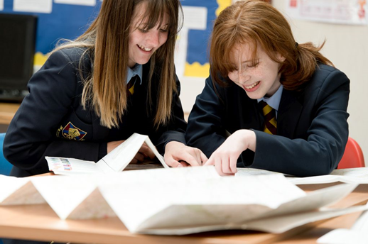

GCSE Business

Why will I enjoy Business?
The GCSE provides an engaging and inspiring course which reflects demands of a truly modern and evolving business environment. It is a qualification that enables students to develop as commercially minded and enterprising individuals and will help them to succeed in their chosen business pathway. The content of the course will reflect all aspects of businesses including finance, marketing, human resources, operations and influences on business. We will also consider businesses in the real world.
What abilities may help me in Business?
- Resilience is of critical importance in Business
- Problem solving skills
- An understanding of different business contexts
- Decision making skills
What will I learn in Business?
Throughout the course we explore a variety of different businesses in the real world as well as looking at some case studies. The first exam will focus on Business in the real world, Influences on Business, Business Operations and Human Resources. The second paper then builds on this further and again looks at Business in the real world, Influences on Business as well as: Marketing and Finance.
How will I get marks in Business?
Lessons will be based around research, as well as written work. You must be able to identify and select different influences on Business and apply it to the real world. You will learn how to produce balanced and well supported responses.
What is the structure of the course?
The course you will follow is AQA GCSE (9-1) Business. A text book and revision guide, which will support the course, is available and this can be found at Waterstones and similar providers. https://www.waterstones.com/book/aqa-gcse-9-1-business-third-edition/malcolm-surridge/andrew-gillespie/9781398356313
https://www.waterstones.com/book/new-gcse-business-aqa-revision-guide-with-online-edition-videos-and-quizzes/cgp-books/cgp-books/9781782946892
GCSE assessment is 100% examination with two written papers, each worth 50%, and lasting 1 hour and 45 minutes.
If I take Business Studies what can I do with it as a career in the future?
Careers which make good use of the skills developed through the study of Business include: Management, business analyst, project manager, estate agent, market researcher, sales manager, brand manager, any role where it is important or useful to have knowledge of a business and how a business is run.
How can I find out more?
https://www.aqa.org.uk/subjects/business/gcse/business-8132
Curriculum Team Leader:
Mrs L Barker

GCSE Computer Science

Why will I enjoy Computer Science?

Computer Science reflects today’s global world – you will develop knowledge and understanding of how technology can be used proactively to help with current issues that impact on modern society; preparing you for your next steps in today’s global world.

What abilities may help me in Computer Science?

- Thinking logically and systematically when problem solving.
- Being able to experiment with different ways of solving problems.
- Having a good level of Maths – you should be comfortable using your Maths skills.
- Being creative when trying to find solutions to new problems.
- Being patient when trying to troubleshoot code.

What will I learn in Computer Science?

Python – a programming language used by NASA, in lots of web applications such as Drop Box and YouTube, as well as by scientists and programmers all over the world.

Awareness of emerging trends in computing technologies, the impact of computing on individuals, society and the environment, including ethical, legal and ownership issues.

Understanding and application of the fundamental principles and concepts of computer science, including abstraction, decomposition, logic, algorithms and data representation.

Analysis of problems in computational terms through practical experience of solving such problems, including designing, writing and debugging programs. Thinking creatively, innovatively, analytically, logically and critically. Understanding the components that make up digital systems and how they communicate with one another and with other systems.

How will I get marks in Computer Science?

You will study a range of tasks – some programming-based and some theory-based. You will need to make sure that you write code that is clearly explained and annotated.

What is the structure of the course?

The course builds on the programming units in Key Stage 3. It is assessed through two written papers at the end of Year 11. Paper 1 focuses on knowledge about how computer systems work.
Paper 2 covers computational thinking and programming.

The content will enable students to move on to A Level Computer Science or BTEC Technical Levels in Computing with a clear knowledge and understanding of the subject.

If I take Computer Science, what can I do with it as a career in the future?

Business Analyst, Database Administrator, Games Developer, Information Systems Manager, IT Consultant, Multimedia Programmer, Search Engine Optimisation (SEO) Specialist, Systems Analyst, Systems Developer, UX Analyst, Web Designer, Web Developer, Digital Copywriter, IT Sales Professional, IT Trainer, Network Engineer, Product Manager.

How can I find out more?

GCSE - Computer Science (9-1) - J277 (from 2020) - OCR

Curriculum Team Leader:
Mrs S Churchward


GCSE Combined Science

Why will I enjoy GCSE Combined Science?

- Studying aspects of Physics, Chemistry and Biology including: waves, energy, the particle model, fuels, atmospheric science, genetics and cells.
- Carrying out a range of practical activities.
- Developing a knowledge and understanding ranging from the very small to the very large.

What abilities may help me in Science?

An ability to evaluate the strengths and weakness of experimental methodology, numeracy, and application of concepts to unfamiliar contexts.

What will I learn in Science?

Knowledge and understanding of:

- Scientific ideas, scientific techniques and procedures.
- Application of knowledge and understanding of scientific ideas, scientific enquiry, techniques and procedures.
- Analysis of information and ideas to interpret and evaluate, to make judgements and draw conclusions and to develop and improve experimental procedures.

How will I get marks in Combined Science?

For Pearson GCSE Combined Science, you will be assessed through 70 minutes of exams that will have a mix of question types to include multiple choice questions, short answers, and longer extended answers (worth up to 6 marks). As it is a double award qualification, students will receive two grades. These grades could be the same number, e.g. 6, 6 or 7, 7. However, some students may receive a grade with adjacent numbers, e.g. 6, 7. This will signify a student who is at an intermediate point between the standard required for a 6, 6 grade, and the standard required for a 7, 7 grade.

What is the structure of the course?

Five hours per week covering 12 units of content based on Physics, Chemistry and Biology. There are 18 core practical’s throughout the course to ensure all students experience the practical and theoretical aspects of the subject. Each unit will have an internally assessed milestone checkpoint that is based on GCSE exam questions. A wide range of teaching and learning activities are utilised including: practical and investigative Science, data logging, 2D and 3D modelling, role-play, visual, audio and kinaesthetic activities. Subject specialists will deliver each aspect of the three Sciences.

If I take Combined Science, what can I do with it as a career in the future?

Science will be a requirement if you wish to pursue: Medicine, Engineering, Environmental Science, Patent Lawyer, Veterinary Science, Cytogenetic Technology, Meteorology, Primary and Secondary school teaching.

How can I find out more?

The GCSE Science Specification and Resources:

https://qualifications.pearson.com/en/qualifications/edexcel-gcses/sciences-2016.html

Curriculum Team Leader:
Mr J Foggo


GCSE Design and Technology:

Why will I enjoy Design and Technology?
Creativity and Innovation: Design and Technology encourages creativity and innovation. You will have the opportunity to brainstorm ideas, solve problems, and bring your creative visions to life through practical projects. Practical Application: This subject is hands-on, allowing you to apply theoretical knowledge to real-world situations. You get to work with a variety of materials and tools, gaining practical skills that can be valuable in various fields. Problem-Solving: Design and Technology involves tackling design challenges and solving problems. It's intellectually stimulating as you find practical solutions to real-world issues, honing your critical thinking and analytical skills. Personalisation: The projects often allow for personalisation, letting you choose topics or themes that genuinely interest you. This freedom fosters a sense of ownership and enthusiasm for your work.
What abilities may help me in Design and Technology?
Creativity: The ability to think outside the box, generate unique ideas, and approach problems from different perspectives is crucial in design and technology. Problem-Solving: Design and Technology often involve overcoming challenges and finding solutions. Strong problem-solving skills will help you navigate through the design process effectively. Critical Thinking: The capacity to analyse information, assess different options, and make informed decisions is essential in evaluating and refining design concepts. Communication Skills: Clear communication is essential when presenting ideas, explaining design choices, and collaborating with classmates or teachers. Both verbal and visual communication skills are valuable. Time Management: Design projects often have deadlines. Being able to manage your time efficiently ensures that you can complete your work on schedule without sacrificing quality. This is particularly important with the NEA aspect of the course.
What will I learn in Design and Technology?
The Design and Technology course is designed to provide students with a broad and practical understanding of design processes, materials, and manufacturing techniques. The syllabus encompasses a range of skills and knowledge areas, and it is structured to encourage creativity, problem-solving, and practical application.

How will I get marks in Design and Technology?
The course is 50% exam (100 marks) and 50% non-examined assessment (100 marks coursework).

What is the structure of the Course?
In Year 10, students will cover a wide range of topics related to Core Technical principles and Specialist Technical principles. Alongside this, they will develop their creative designing and prototyping making skills in minor projects. Year 11 will have a high focus on the successful completion of the non-exam assessment honing skills learnt in Year 10. Alongside this, students will apply their knowledge and understanding to exam related topics in preparation for the final exam in June.

If I take Design and Technology, what can I do with it as a career in the future?
Choosing GCSE Design and Technology can open up various career paths, as it equips you with a valuable set of skills that are applicable in a range of industries. Students will be qualified to further study a Design and Technology related subject, or embark on an apprenticeship. Design and technology can set you up for a career in a wide variety of industries such as product designing, engineering, architecture, carpentry, information technology, and even education. Skills gained from GCSE Design and Technology, such as problem-solving, creativity, project management, and technical proficiency, are transferable across various industries, giving you flexibility in choosing a career that aligns with your interests and strengths.

How can I find out more?
You can visit the AQA website for further information, guidance, support and resources at www.aqa.org.uk/8552 or simply come and talk with any of the teachers in the Technology team.
For Design & Technology students are asked to make a small financial contribution towards the cost of materials for their NEA projects, this is requested at the start of the course and is just £5.00.
Curriculum Team Leader:
Mr T Richards

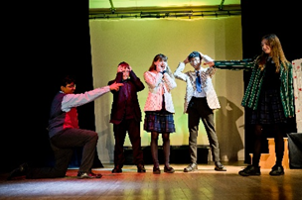
Performing Arts Technical Award

Why will I enjoy Performing Arts?
Do you have a passion for Performance? Are you a budding actor, dancer or singer? Do you want to discover more about the fantastic roles behind the scenes-from costume design and make up, to set design and lighting?
If so it’s time to find out about this exciting qualification.
What skills will I develop in Performing Arts?
You will develop a range of skills which are attractive to employers, colleges and universities including:
Communication Confidence Problem solving
Learning independently Organisation Research
Self- Discipline Stamina Taking on responsibility
What will I learn in Performing Arts?
Unit 1- Performing
You will learn the skills and techniques needed to produce a successful performance of an existing work, such as an extract from a play or show. This unit can be completed through either of the following disciplines: Drama or Musical Theatre (which may incorporate dance).
Unit 2- Creating
You will learn how to create and refine your own original work in performing arts, such as choreography, designing costumes or performing. This unit can be completed through any one of the following disciplines: devised drama, choreography, costume design, lighting design, make-up and hair design, set design, sound design.
Unit 3- Performing Arts in Practice
You will learn about areas of the performing arts industry that need to be considered when responding to a commission and will consider these when coming up with and pitching you own idea.
How will I get marks in Performing Arts?
For Units 1 and 2 you will undertake projects (not exams) in response to briefs. The project for each unit will take 10 hours and be worth 30% of your qualification. For each one you will be given a scenario and will need to undertake a number of tasks.
In Unit 3 you will undertake another project (no exam) in response to a brief, which will take 20 hours and be worth 40% of your qualification. You will be given a scenario and will need to undertake a number of tasks.
If I take Performing Arts, what can I do with it as a career in the future?
The Performing Arts industry offers you a wide range of exciting opportunities which includes
Actor Arts Administrator Community arts worker
Choreographer Dancer Lighting/sound technician
Director Drama/music therapist Front of house/stage manager
Designer Musical Theatre performer Teacher
How can I find out more?
Eduqas Level1/2 Vocational Award in Performing Arts (Technical Award)
https://www.eduqas.co.uk/qualifications/level-12-vocational-award-in-performing-arts#tab_keydocuments
Curriculum Team Leader: Mr H Sutton

GCSE English Language

Why will I enjoy GCSE English Language?

- Reading and exploring a range of exciting quality fiction texts.
- Learning about non-fiction writing from 19th, 20th and 21st Century writers.
- Learning to read critically and using the knowledge gained to improve your own writing.
- Discovering and using new terminology and linguistic conventions for reading, writing and spoken Language.
- Practical and creative activities to explore texts.

What abilities may help me in English Language?

- Enjoyment of reading and reading with fluency.
- Clear expression in the written form.
- A creative and inventive imagination.
- Confidence to express your ideas in front of others.
- Good competency with spelling, use of punctuation, and grammar.

What will I learn in English Language?

You will learn to read and absorb a wide range of texts fluently and write effectively about them demonstrating confident control of Standard English. You will develop a wide vocabulary, along with a knowledge and understanding of grammatical terminology and how to use it appropriately. As part of the course you will prepare an individual spoken language presentation.

How will I get marks in GCSE English Language?

Your AQA English Language GCSE will be assessed by two external examinations at the end of the course. Paper 1, ‘Explorations in creative reading and writing’, comprises of two equally weighted sections: reading and writing. Section A presents an engaging 20th/21st Century fiction text to which you will respond. Section B requires you to write creatively and with use of linguistic devices, inspired by the topic that you have responded to in section A. This examination is 50% of the qualification. Paper 2, ‘Writers’ viewpoints and perspectives’, once again comprises of two equally weighted sections. In section A you will be asked to consider two linked non-fiction sources from different time periods and explore writers’ perspectives. For section B you will write for a specified audience, purpose and form.

What is the structure of the course?

During Year 10 you will study the skills required to approach both sections of paper 1 and paper 2. These units are interspersed with units from the Literature course. Milestone assessments will be undertaken to measure your progress towards mastering analytical and writing skills necessary for success with this qualification. In Year 11 you will revisit the papers and undertake practice questions regularly to build confidence and competency.

If I take English, what can I do with it as a career in the future?

English is a requirement if you wish to pursue further studies or a career in: Law, Journalism, Teaching, Media, Humanities, Creative Writing, Editing, Politics, Research, Public Relations. It is also a useful tool to have and apply in any subjects with a written or communicative component, such as: Business, Service industry, Administrative work, Social work, Marketing and Sales to name but a few.

How can I find out more?

AQA GCSE English Language (8700) www.aqa.org.uk/subjects/english/gcse/english-langauge-8700

Curriculum Team Leader:
Miss S Griffiths

GCSE English Literature


Why will I enjoy GCSE English Literature?

- Reading and exploring a range of exciting quality fiction texts from our English Literary Heritage.
- Learning to empathise with characters and situations.
- Learning to read critically and using the knowledge gained to improve your own writing and analysis.
- Practical and creative activities to explore texts.
- Opportunities to see texts in action through theatre visits / media resources.

What abilities may help me in English Literature?

- Enjoyment of reading and reading with fluency.
- Empathy with shaped characters and situations.
- Understanding of authors’ intentions clearly in the written form.
- Good competency with spelling, use of punctuation, and grammar.

What will I learn in English Literature?

You will learn to read and appreciate a wide range of texts which span 500 years of writing from our English Literary Heritage. You will learn to understand how writers shape characters, themes and structure the text. Close textual analysis will be studied, along with structural features of the texts. Set texts are: ‘Blood Brothers’ by Willy Russell; ‘Macbeth’ by William Shakespeare; ‘The Sign of the Four’ by Arthur Conan Doyle; ‘Love and Relationships’ poetry anthology. The poetry component requires comparison between the poems, an unseen poem analysis and an unseen poetry comparison.

How will I get marks in GCSE English Literature?

Your AQA English Literature GCSE will be assessed by two external examinations at the end of the course. Paper 1, ‘Shakespeare and the 19th century novel’, is worth 40% of the GCSE. Section A requires a response to an extract from ‘Macbeth’ and then to write about the play as a whole. Section B requires an essay response to ‘The Sign of the Four’, prompted by a printed extract. Paper 2 ‘Modern Texts and Poetry’, is worth 60% of the GCSE. Section A features an essay question relating to the play, ‘Blood Brothers’. Section B is a poetry comparison question based on studied poems from the AQA Anthology. Section C comprises of two questions; one relating to an unseen poem, the second presents another unseen poem and requires some comparisons to be made.

What is the structure of the course?

During Year 10 you will study the play, ‘Blood Brothers’ and the 19th Century text, ‘The Sign of the Four’. You will also learn about poetry and study half of the poems from the AQA Anthology. These units are interspersed with units from the Language course. Milestone assessments will be undertaken to measure your progress towards mastering the analytical skills necessary for success with this qualification. In Year 11 you will study Macbeth and the remaining poems. We will revisit all texts to revise on a rotational basis and undertake practice questions regularly to build confidence and competency.

If I take English Literature, what can I do with it as a career in the future?

English Literature is a desirable qualification to have if you wish to pursue further studies or a career in: Law, Journalism, Teaching, Media, Humanities, Creative Writing, Editing, Politics, Research, Public Relations.

How can I find out more?

AQA GCSE English Literature (8702) http://www.aqa.org.uk/subjects/english/gcse/english-literature8702

Curriculum Team Leader:
Miss S Griffiths

GCSE Food Preparation and Nutrition
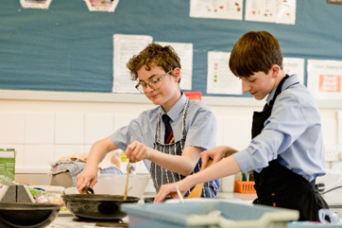
Why will I enjoy Food Preparation and Nutrition?
- A new and exciting creative course which focuses on practical cooking skills.
- Demonstrating knowledge and understanding of nutrition, food, cooking and preparation.
- Applying knowledge and understanding of nutrition, food, cooking and preparation.
- Planning, preparing, cooking and presenting dishes, combining appropriate techniques.
- Analysing and evaluating different aspects of nutrition, food, cooking and preparation including food made by yourself and others.

What abilities may help me in Food Preparation and Nutrition?
- The ability to research and analyse a chosen task.
- The ability to make and trial dishes, including the demonstration of different cooking techniques.
- The ability to justify the choice of dishes you have made.
- The ability to plan, prepare, cook and present dishes within the lesson time allocated.
- The ability to analyse and evaluate the nutritional, cost and sensory properties (using ICT) of the dishes you make.
- The ability to create and collate photographic evidence of your practical work showing final outcomes.

What will I learn in Food Preparation and Nutrition?
The course should enable you to:
- Demonstrate effective and safe cooking skills by planning, preparing and cooking using a variety of food commodities, cooking techniques and equipment.
- Develop knowledge and understanding of the functional properties and chemical processes as well as the nutritional content of food and drinks.
- Understand the relationship between diet, nutrition and health, including the physiological and psychological effects of poor diet and health.
- Understand the economic, environmental, ethical and socio-cultural influence on food availability, production processes and diet and health choices.
- Demonstrate knowledge and understanding of microbiological food safety when preparing, processing, storing, cooking and serving food.
- Understand and explore a range of ingredients and processes from different culinary traditions (British and International) to inspire new ideas or modify existing recipes.

How will I get marks in Food Preparation and Nutrition?
Paper 1: Food preparation and nutrition (50%) Written Exam: 1 hour 45 minutes. (100 Marks) – 20 multiple choice questions and five questions each with a number of sub sections worth 80 marks. Non-exam assessment (NEA): (50%) Task 1: Food Investigation. (30 Marks) Written or electronic report including photographic evidence of a practical investigation to show the working characteristics, functional and chemical properties of ingredients. Task 2: Food Preparation Assessment (70 Marks): Students will prepare and cook and present a final menu of three dishes within a single three hour period, planning in advance how this will be achieved.

What is the structure of the course?
In Year 10 the majority of key learning will be covered in the following five core topics: Food, Nutrition and Health, Food Science, Food Safety, Food Choice and Food Provenance. This allows students to apply this learning when working on the non-exam assessment (NEA) and examination paper in Year 11. In Year 11, students will undertake the two practical non- exam assessed tasks. Task 1 = Written or electronic report (1500-2000 words) including photographic evidence of a practical investigation and Task 2 = Preparation, cooking and presentation of three dishes in a single three hour period supported by a portfolio including photographic evidence. There is also an exam of 1 hour 45 minutes.

If I take Food and Nutrition, what can I do with it as a career in the future?
Upon completion of this course, students will be qualified to go on to further study, or embark on an apprenticeship or full time career in the catering or food industry. Higher Education (Degrees at University): Food and Nutrition. Food Marketing and Management, Nutrition and Dietetics, Food Science, Food Science and Manufacturing, Food and Business, Food and Consumer Studies etc.

How can I find out more?
The AQA Food Preparation and Nutrition specification and resources: http://www.aqa.org.uk/8585

Curriculum Team Leader:
Mr T Richards

GCSE Languages (French)
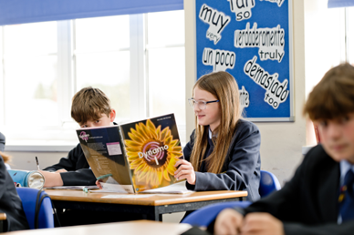
Why will I enjoy French?
There are varied activities in lessons: listening to songs, watching videos; reading articles, book extracts, comics; talking French with others in pairs, groups, with your teacher or other adults; writing letters, articles, messages, describing pictures. You will enjoy using language which you have learnt to express your ideas and opinions. You will enjoy developing your interpersonal and communication skills and your confidence.

What abilities may help me in French?
- You need to have studied French at KS3 to do GCSE.
- An ability to think clearly and to persevere at tasks is useful.
- You need to be able to memorise vocabulary.
- An openness to learning about other cultures is important.

What will I learn in French?
You will learn to write, speak, read and listen to French and understand what is being said. You will learn to write and talk about your life and experiences. You will learn about the culture and customs of France and French-speaking countries. The thematic contexts of this course are: My personal world - Lifestyle and wellbeing - My neighbourhood - Media and technology - Studying and my future - Travel and tourism.

How will I get marks in French?
There are 4 different exam papers to complete. Each paper counts as 25% towards the overall grade.
- Speaking - Tasks include: reading aloud, a transactional role play, a picture description and follow on conversation (you can select your topic from a choice of 2 a couple of weeks before the exam, so you know what the conversation will focus on).
- Listening and understanding - Each extract will be played 3 times so that you can listen, respond and then check.
The extract will be spoken at a moderate pace and there will be gaps built in to give you time to answer.
Questions types (all questions are set in English): multiple-choice, multiple-response and short-answer open response questions and a dictation (when you write what you hear, some gap-fill and some full sentences).
- Reading and understanding - Questions types (all questions are set in English): multiple-choice, multiple-response and short-answer open response questions plus a translation into English.
- Writing – tasks include a picture description (foundation only), open response writings (Foundation = 40-50 words & 80-90 words. Higher = 80-90 words and 130-150 words) with a choice of two for each so you can pick the one you feel more confident with. All of the question instructions will be written in English. There is a translation into French – 5 sentences for Foundation, a short paragraph for Higher.
What is the structure of the course?
During years 10 and 11 you will study different topics, from the list above. As you move through the topics and increase your knowledge of vocabulary and grammar, you will learn how to complete the different types of task which will be set in the exams (role plays, photo tasks, letters, articles, translations).

If I take GCSE French, what can I do with it as a career in the future?
Careers involving languages include working with companies which trade internationally – there are many of these in Hereford and the area. Linguists can be involved in translation, tourism, politics, the media and journalism, as well as working in food production, industry, marketing, sport and other areas. Knowledge of other languages can help in the fields of law, medicine and engineering. Just having a GCSE in a language shows an employer lots about you and improves your CV, as they will know that you are someone who works hard, shows commitment, has good communication skills and is able to solve problems. It also shows that you have an open, inquisitive mind about the world.

How can I find out more?
As well as asking your teacher, here is a link to the exam board site, where you can find additional information about the NEW GCSE in French.
2024 MFL GCSEs: Qualification at a glance (pearson.com)

Curriculum Team Leader: Mrs K Greenwood

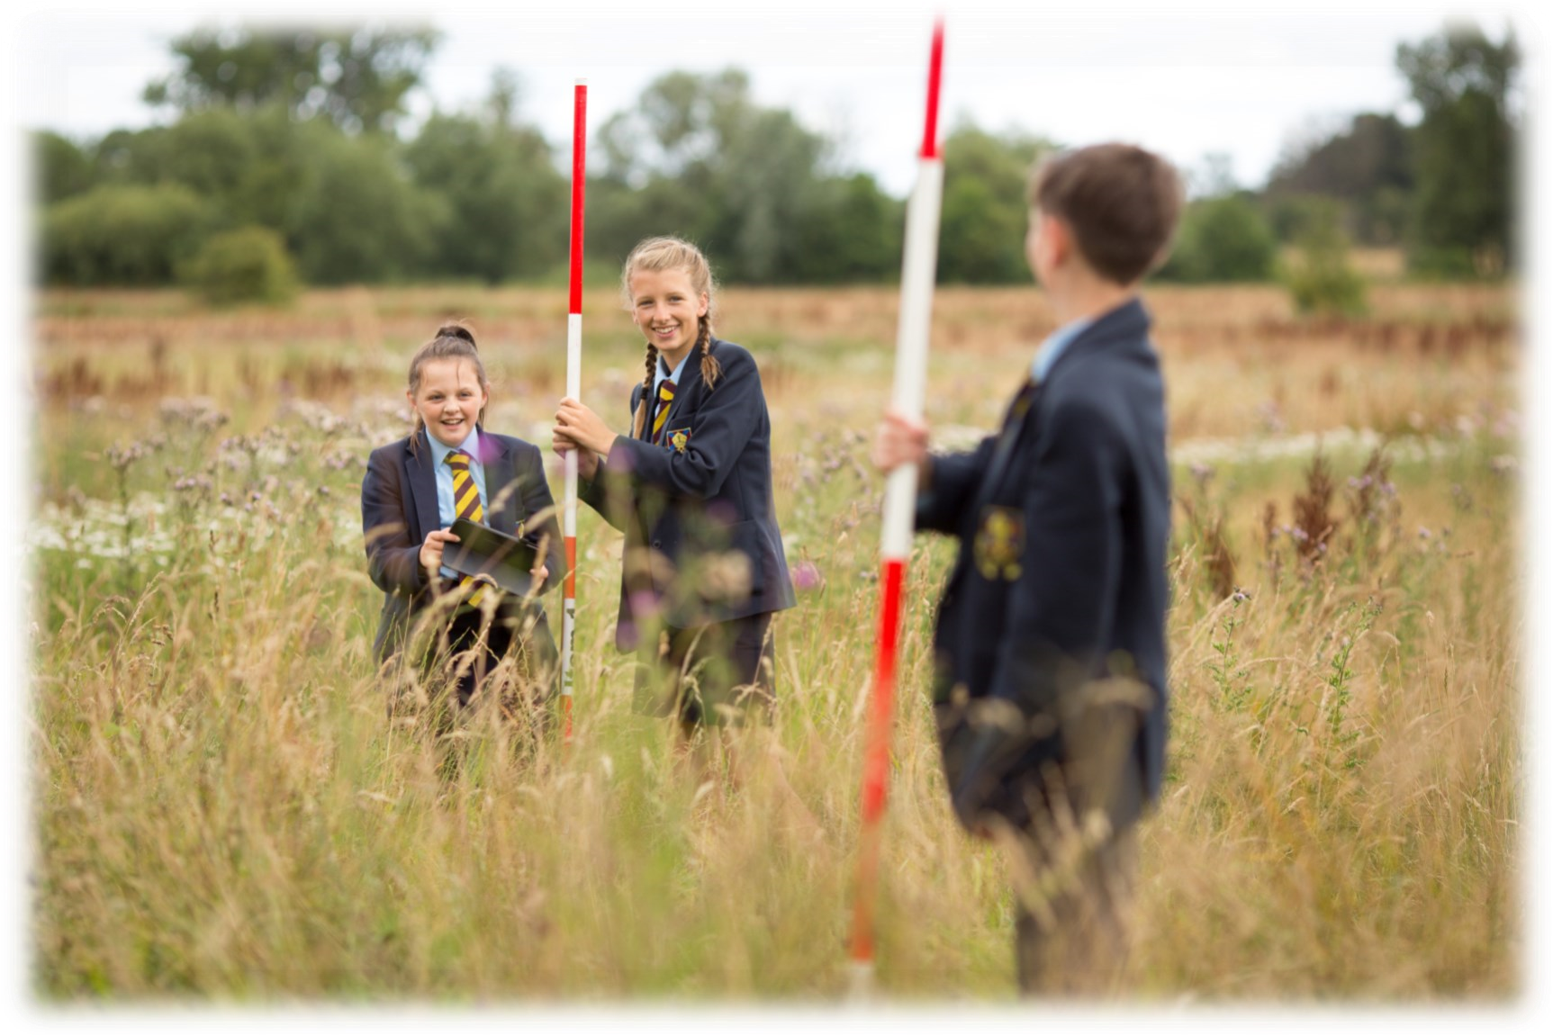
GCSE Geography

Why will I enjoy Geography?

Studying Geography gives you the opportunity to travel the world via the classroom, learning about both the physical and human environment. You’ll understand how Geography impacts your life every day and discover the key opportunities and challenges facing the world.

What abilities may help me in Geography?

- An interest in the world around you.
- Good numeracy and literacy skills.
- Being able to collect then analyse data in order to make conclusions.
- Geography is a real crossover between the Science and Arts subjects like English and History.

What will I learn in Geography?

Living with the physical environment:
Discover more about the challenge of natural hazards and the living world, physical landscapes of the United Kingdom and human interaction with them. This unit develops an understanding of the tectonic, geomorphological, biological and meteorological processes and features in different environments. It provides you with the knowledge about the need for management strategies governed by sustainability and consideration of the direct and indirect effects of human interaction with the Earth and the atmosphere.

Challenges in the human environment:
This unit is concerned with human processes, systems and outcomes and how these change both spatially and temporally. You will develop an understanding of the factors that produce a diverse variety of human environments; the dynamic nature of these environments that change over time and place; the need for sustainable management; and the areas of current and future challenge and opportunity for these environments.

Geographical applications:
This is split into two very distinct parts an issues evaluation section and a geographical skills section. The issues evaluation paper will require you to apply your geographical skills and knowledge gained from the course to evaluate and ultimately make a decision on a geographical issues given in a pre-release material. e.g. 2018 paper was locating a reservoir in Oxfordshire.
The geographical skills section requires you to apply your knowledge and skills gained through geographical fieldwork, which you have been involved in throughout the course.

How will I get marks in Geography?

You will have three written exams. Papers 1 and 2 are 1 hour 30 minutes long and together, they contribute to 70% of your final mark. Paper 3 is 1 hour 15 minutes and contributes to the final 30% of your GCSE grade.

What is the structure of the course?

Paper 1: Living with the physical environment
Paper 2: Challenges in the human environment
Paper 3: Geographical applications

If I take Geography, what can I do with it as a career in the future?

Choose GCSE Geography and you will learn how today’s world was shaped and understand the challenges we face in the future. You will also examine the Earth’s natural resources and the increasing battles between the man-made and natural world. This knowledge, paired with your essential curiosity, will give you the sought-after transferable skills for success in further education and the workplace.
Possible careers may include: Travel writer, Expedition leader, Cultural arts officer, Aid worker, Diplomat, Lawyer, Retail management, Coastal engineer, Teacher, Military GIS specialist, Aerial surveyor, Pollution analyst, Conservation officer

How can I find out more?
http://www.aqa.org.uk/subjects/Geography/gcse/Geography-8035

Curriculum Team Leader:
Mr A Banks


GCSE History

Why will I enjoy GCSE History?

It is interesting and the range of units means it will be different from what you have studied in KS3. There are possibilities for visits, both within the UK and also abroad, although these are not a compulsory element of the course.

What abilities may help me in History?

- A passion for the past.
- A love of enquiry.
- A good work ethic.
- An ability to ask questions and then look for answers.

What will I learn in History?

You have started the first GCSE History unit at the beginning of Year 9. It is on Germany 1890-1945, and covers issues like Kaiser Wilhelm II’s reign, Weimar Germany and the Nazi era.

In Year 10 you will study Conflict and Tension 1889 - 1918. This covers the causes, events and initial consequences of the First World War. You will then move on to a study of Norman England, including the swap from Anglo-Saxon to a Norman system of government, conflicts and issues during the early years of the Norman conquest and also Norman developments into Wales.

In Year 11 you will study Britain: The health and the people, c. 1000 – present day. You will also have plenty of revision of the earlier units.

How will I get marks in History?

Completing all classwork is very important, plus making use of the exam questions and mark schemes that we will share with you. Revision should be built up right from the beginning, as learning little and often helps the knowledge to stick. Knowledge is important in this course.

The course is 100% final exam, split over two papers.

What is the structure of the course?

Paper 1 - Understanding the modern world
This paper covers Germany 1890-1945: Democracy and dictatorship and Conflict and tension: The First World War 1894 – 1918.
Paper 2 – Shaping the nation
This paper covers Britain: Health and the people: c1000 to present day and Norman England c.1066 – c.1100.

If I take History what can I do with it as a career in the future?

All sorts! History teaches you to think, analyse and interpret. This helps with a range of jobs and life experiences. Obvious career choices include law, the military, public services, but also accountancy and banking, where analysis is important.

How can I find out more?

http://www.aqa.org.uk/subjects/history/gcse/history-8145

Curriculum Team Leader:
Mr A Banks

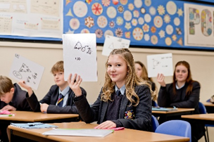
GCSE Mathematics

Why will I enjoy Mathematics?

- Developing your problem solving skills.
- Improving your calculation skills and gaining a sense of satisfaction when you discover how to reduce a seemingly difficult calculation to a much simpler form.
- Developing your spatial awareness and your ability to visualise problems in both 2D and 3D.
- Gaining an understanding of statistical analysis and the way the data cycle works to enhance your knowledge of real life situations.

What abilities may help me in Mathematics?

- Thinking logically and systematically when problem solving.
- Having good arithmetic skills which allow you to make choices about the methods you use depending on the numbers you are working with and the degree of accuracy required.
- Creative thinking when tackling unfamiliar tasks.
- Sound understanding of concepts.
- Fluency in procedural skill.

What will I learn in Mathematics?

The subject is divided into six strands:

- Algebra - where you develop general concepts in an abstract form.
- Number - which will enable you to choose appropriate calculations for the task.
- Ratio, proportion and rates of change.
- Geometry and Measure - where your spatial awareness is enhanced.
- Statistics – where you use the data cycle for analysing and solving problems.
- Probability - where you apply ideas of randomness, fairness and equally likely events.

How will I get marks in Mathematics?

Most of your marks will be gained by showing your working out when answering questions and then getting bonus marks for getting the correct answer.

What is the structure of the course?

The course builds upon Key Stage 3 studies and is assessed through three written papers at the end of Year 11. Set 1 students also study units from the AQA Level 2 Certificate in Further Mathematics.

If I take Mathematics, what can I do with it as a career in the future?

Examples of careers you could investigate are:

Accounting, Architecture, Banking, Insurance, Economics, Engineering, Medicine, Psychology. Physiotherapy, Teacher training (any subject) and many more…

How can I find out more?
http://www.mathscareers.org.uk https://qualifications.pearson.com/en/qualifications/edexcel-gcses/mathematics-2015.html

Curriculum Team Leader:
Mrs S Churchward

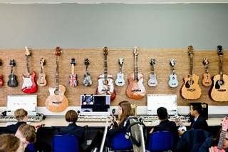
GCSE Music

What will I enjoy in Music?

Broadening your musical tastes and experiences through performing, composing and listening. You will learn or develop skills on an instrument of your choice. Individual and group tuition is available from 20 tutors in school. You will be able to listen to a wide selection of music including popular, world music and classical music.

What abilities may help me in Music?

GCSE music is designed for everyone who has an interest in music, so if you like being involved with Music, through playing or singing, then this course is for you. If you already play an instrument, you have a head start especially if you’re used to playing instruments with other people. You will have created compositions in Key Stage Three and these will help you create more at Key Stage Four.

What will I learn in Music?
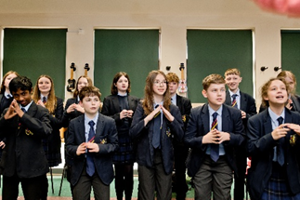
You will learn how to perform on an instrument and how to perform with others. You will create two compositions of differing styles and listen to a wide range of musical styles.

How will I get marks in Music?
30% of the total marks are awarded to the production of two compositions. 40% of the marks are awarded to your listening skills where you learn to identify key music words and styles. This is assessed through a listening exam complete with music.
30% of the marks are assessed by the performance of two pieces; one to demonstrate your own solo skills and a second with other players. This is recorded in the classroom.

What is the structure of the course?

40% of the course is based on listening to a wide variety of music. You will be issued with PowerPoints and work sheets that teach you how to listen to Music’s key elements. Homework tasks take the form of composition, listening exercises and research and of course practising your performing! 30% of the course is spent on composing music using a choice of three software packages, i.e. Logic Pro, Sibelius or Garage band.
Finally, the last 30% of the course can be linked with your private or school based tutor when you learn two pieces of your choice. There are lessons when you are encouraged to practice your pieces in class, so staff can monitor your skills and your progress.

If I take Music, what can I do with it as a career in the future?

GCSE music is a great qualification for any further qualification such as AS and/or A-level in Music or Music Technology. It also acts as a good start to any further level 2 or 3 qualifications such as BTEC or other diploma. It will give you a good basis for any further careers in the Arts. Music GCSE will help you to go on the stage, work as a studio engineer, work as a musician in radio or live performance, teaching music (primary/secondary), music therapy, peripatetic music teacher, composing music for media (games, TV themes and film music), presenter in the media, radio DJ, etc. There are many careers that expect music as part of the job. If you are wanting to go to university music is a good subject to include in your application.

How can I find out more?
https://www.eduqas.co.uk/qualifications/music-gcse/#tab_keydocuments

Curriculum Team Leader:
Mr H Sutton

Physical Education GCSE / CNAT

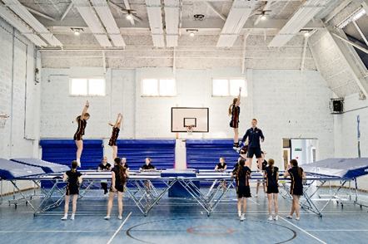
This year the PE department is offering two qualifications in PE. Teachers will select which course they feel would best suit you and your learning style:
- Edexcel GCSE PE
- OCR National Sport Studies

What will I enjoy about PE?
Both courses combine practical and theoretical content, covering broad and topical areas that will enable you to learn about the benefits of a healthy, active lifestyle alongside further enhancing your skills and performance in sport.

What abilities may help me in PE?
- Be passionate about physical activity, sport, both in terms of participating and understanding the human anatomy and science behind how the body works during physical activity
- The content of the course is mainly theory and will be very academically challenging
- You will need to have the ability to apply theory to practical settings to get the most out of the course
- The ability to perform practically in a range of activities
- Extra-curricular attendance is encouraged to further support both practical and theoretical application
- Confidence in science is integral to the course
- To be able to work independently
- You will be required to work independently on applying the knowledge gained in the theory to your chosen practical activities; this of course should improve your performances

What will I learn in PE?
- Students will develop a theoretical knowledge and understanding of the factors that underpin physical activity and sport and use this knowledge and understanding to improve performance
- Understand how the physiological and psychological state affects performance
- Perform effectively in different physical activities by developing skills and techniques and selecting and using tactics, strategies and/or compositional ideas
- Develop your ability to analyse and evaluate to improve performance
- Take on the role of a leader or officiator within lessons
- Understand the contribution that physical activity and sport make to health, fitness and well-being

How will I get assessed in PE?
Edexcel GCSE PE:  You will be assessed by two externally examined papers and two non-examined assessments (70% theory / 30% practical).  Components:  Component 1: Fitness and Body Systems (36%)  - Applied Anatomy and Physiology  - Movement Analysis  - Physical Training  Component 2: Health and Performance (24%)  - Health, Fitness and Well-being  - Sports Psychology  - Socio-cultural influences  Component 3: Practical performance (30%)  - 3 x performances (individual and team sports)  Component 4: Personal Exercise Programme (10%)  - Planning, carrying out and monitoring the PEP  - Evaluation of PEP |  | OCR National Sport Studies  You will be assessed in one externally examined paper and two non-examined assessments.  Units:  Unit 1: Contemporary Issues in Sport (40%)  - Issues which affect participation in sport  - Role of sport in promoting values  - The implications of hosting a major sporting event  - The role of NGB’s in developing sport  - Use of technology in sport  Unit 2: Performance and Leadership in Sports Activities (30%)  - Key components of performance  - Applying practice method of support improvement in a sporting activity  - Organising and planning a sports activity session  - Leading a sports activity session  - Reviewing own performance  Unit 3: Increasing awareness of OAA (30%)  - Provision for OAA  - Equipment and safety  - Plan and participate in OAA  - Evaluate participation performance in OAA
If I take PE, what can I do with it as a career in the future?
Physical Education lends itself to a range of careers in sports and fitness. For example, Sport Scientist, Sport Psychologist, Nutritionist/ Dietician, Physical Therapist, PE Teacher, Physiotherapist, Health and Sport Development Officer, Professional Sportsperson, Sports Coach/Consultant, Fitness Instructor/Personal Trainer.

How can I find out more?
GCSE PE : GCSE Physical Education 2016: Specification
Sports Studies: Cambridge Nationals - Sport Studies Level 1/Level 2 – J829 (ocr.org.uk)

Curriculum Team Leader:
Miss J Chadderton

GCSE Religious Studies

Why will I enjoy Religious Studies?

The GCSE provides a modern approach to studying issues related to religion. The content of the course will reflect current issues that you see or read about in the news. You will evaluate the importance of right and wrong and learn to interpret moral codes and justify moral choices. The study of religion develops key transferable skills. These skills include interpreting and evaluating pieces of information together with communicating and applying knowledge to solve problems. You also have an opportunity to develop debating/speaking and listening skills.

What abilities may help me in Religious Studies?

- Arrive to all lessons with an open mind ready to face the challenge of exploring your own views and the views of others.
- We deal with sensitive topics, so a respect for others is essential.
- Resilience is of critical importance in Religious Studies.
- Empathy is vital if you are going to be able to critically evaluate the issues we explore.

What will I learn in Religious Studies?

Throughout the course we explore and consider a variety of world views. The first exam will focus on the beliefs, teachings and practices of Christianity and Islam. The second paper then builds on this through the study of four key themes. We focus on; Relationships and Families, Matters of life and death, Religion and Conflict, Religion, and Crime and Punishment.

How will I get marks in Religious Studies?

Lessons will be based around discussion, as well as written work. You must be able to identify and select differing religious views about various topics and then express and fully develop your own view. You will learn how to produce balanced and well supported responses.

What is the structure of the course?

The course you will follow is AQA GCSE (9-1) Religious Studies Specification A. A text book, which will support the course, is available and this can be found at Waterstones and similar providers. https://www.waterstones.com/ book/aqa-gcse-9-1-religious-studies-specification-a-specification-a/lesley-parry/jan-hayes/9781471866852 . GCSE assessment is 100% examination with two written papers, each worth 50%, and lasting 1 hour and 45 minutes.

If I take Religious Studies what can I do with it as a career in the future?

Careers which make good use of the evaluative skills developed through the study of Religion include: Law, Social work, University Lecturer, Banker, Politician, Management, Psychology, Police work (forensic), Journalism. Careers where it is important or useful to have knowledge of what really matters to people: Health Care, Child Care, Medicine, Psychologist, Customer Services and many more.

Careers where you need specific knowledge of religions include: Teaching, University Lecturer, Social work, Archaeology, Museum work, Fine Art, Conservatory/Natural History, Architecture, Youth work and Ministry.

How can I find out more?

http://www.aqa.org.uk/subjects/religious-studies/gcse/religious-studies-a-8062

Curriculum Team Leader:
Mrs L Barker

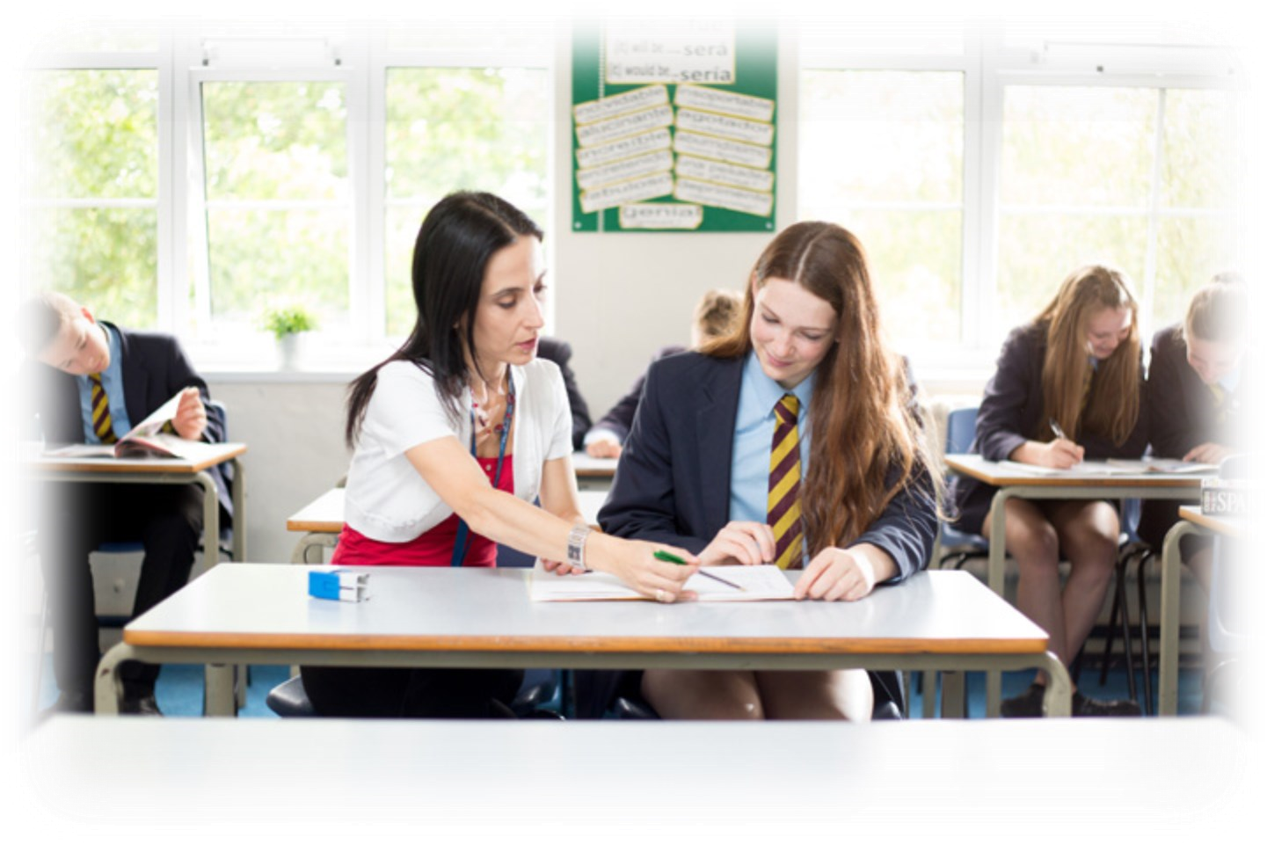
GCSE Languages (Spanish)

Why will I enjoy Spanish?
There are varied activities in lessons: listening to songs, watching videos; reading articles, book extracts, comics; talking Spanish with others in pairs, groups, with your teacher or other adults; writing letters, articles, messages, describing pictures. You will enjoy using language which you have learnt to express your ideas and opinions. You will enjoy developing your interpersonal and communication skills and your confidence.

What abilities may help me in Spanish?
- You need to have studied Spanish at KS3 to do GCSE.
- An ability to think clearly and to persevere at tasks is useful.
- You need to be able to memorise vocabulary.
- An openness to learning about other cultures is important.

What will I learn in Spanish?
You will learn to write, speak, read and listen to Spanish and understand what is being said. You will learn to write and talk about your life and experiences. You will learn about the culture and customs of France and Spanish-speaking countries. The thematic contexts of this course are: My personal world - Lifestyle and wellbeing - My neighbourhood - Media and technology - Studying and my future - Travel and tourism.

How will I get marks in Spanish?
There are 4 different exam papers to complete. Each paper counts as 25% towards the overall grade.
- Speaking - Tasks include: reading aloud, a transactional role play, a picture description and follow on conversation (you can select your topic from a choice of 2 a couple of weeks before the exam, so you know what the conversation will focus on).
- Listening and understanding - Each extract will be played 3 times so that you can listen, respond and then check.
The extract will be spoken at a moderate pace and there will be gaps built in to give you time to answer.
Questions types (all questions are set in English): multiple-choice, multiple-response and short-answer open response questions and a dictation (when you write what you hear, some gap-fill and some full sentences).
- Reading and understanding - Questions types (all questions are set in English): multiple-choice, multiple-response and short-answer open response questions plus a translation into English.
- Writing – tasks include a picture description (foundation only), open response writings (Foundation = 40-50 words & 80-90 words. Higher = 80-90 words and 130-150 words) with a choice of two for each so you can pick the one you feel more confident with. All of the question instructions will be written in English. There is a translation into Spanish – 5 sentences for Foundation, a short paragraph for Higher.
What is the structure of the course?
During years 10 and 11 you will study different topics, from the list above. As you move through the topics and increase your knowledge of vocabulary and grammar, you will learn how to complete the different types of task which will be set in the exams (role plays, photo tasks, letters, articles, translations).

If I take GCSE Spanish, what can I do with it as a career in the future?
Careers involving languages include working with companies which trade internationally – there are many of these in Hereford and the area. Linguists can be involved in translation, tourism, politics, the media and journalism, as well as working in food production, industry, marketing, sport and other areas. Knowledge of other languages can help in the fields of law, medicine and engineering. Just having a GCSE in a language shows an employer lots about you and improves your CV, as they will know that you are someone who works hard, shows commitment, has good communication skills and is able to solve problems. It also shows that you have an open, inquisitive mind about the world.

How can I find out more?
As well as asking your teacher, here is a link to the exam board site, where you can find additional information about the NEW GCSE in Spanish.
- 2024 MFL GCSEs: Qualification at a glance (pearson.com)

Curriculum Team Leader: Mrs K Greenwood

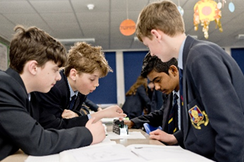
GCSE Triple Science (Physics, Chemistry, Biology)

Why will I enjoy Triple Science?
- Studying Physics, Chemistry and Biology including: waves, energy, the particle model, fuels, atmospheric science, genetics and cells, organic chemistry, food security and optics.
- Carrying out a range of practical activities.
- Developing a knowledge and understanding ranging from the very small to the very large.

What abilities may help me in Science?
Evaluation of the strengths and weakness of experimental methodology, numeracy, application of concepts to unfamiliar contexts.

What will I learn in Science?
Knowledge and understanding of: scientific ideas, scientific techniques and procedures.

Application of knowledge and understanding of: scientific ideas, scientific enquiry, techniques and procedures.

Analysis of information and ideas to: interpret and evaluate, to make judgements and draw conclusions and to develop and improve experimental procedures.

How will I get marks at GCSE?

For each of the Pearson GCSE Physics, Chemistry and Biology qualifications you will be assessed through 2 x 1 hour 45 minute exams that will have a mix of question types to include multiple choice questions, short answers, and longer extended answers (worth up to 6 marks).

As they are separate qualifications students will receive three separate grades, one for each subject.

Students will have to study all 3 Sciences.

What is the structure of the course?
Seven hours per week covering 33 units of content based on Physics, Chemistry and Biology. There are 21 Core practical’s throughout the course to ensure all students experience the practical and theoretical aspects of the subjects. Each unit will have an internally assessed milestone checkpoint that is based on GCSE exam questions. A wide range of teaching and learning activities are utilised including: practical and investigative Science, data logging, 2d and 3d modelling, role-play, visual, audio and kinaesthetic activities. Subject specialists will deliver each aspect of the three Sciences.

If I take Triple Science, what can I do with it as a career in the future?
Science will be a requirement if you wish to pursue: Medicine, Engineering, Environmental Science,
Patent Lawyer, Veterinary Science, Cytogenetic Technology, Meteorology, Primary and Secondary school teaching.

Entry Criteria:
We will only run one Triple Science group. The students who make this preference should have an EPT of at least a grade 6 and:
- Have a passion for Science and are proactive in developing their knowledge and understanding. Studying Science at both A Level and at University is a priority.
- Are driven to succeed in Physics, Chemistry and Biology as they form the three components for Separate Science.
- Are likely to achieve at least a Grade 6+ at KS4 and will be entered for Higher Tier exam papers.
- Are able to work independently selecting appropriate resources and are self-motivated.
- Prepare well for challenging exams by attending revision sessions.
- Have the ability to retain information and apply skills over a long period (2 years).

How can I find out more?
The GCSE Physics, Chemistry and Biology Specification and Resources:

https://qualifications.pearson.com/en/qualifications/edexcel-gcses/sciences-2016.html

Curriculum Team Leader:
Mr J Foggo

Cambridge National in Creative iMedia

Why will I enjoy Creative iMedia?
- Have you enjoyed the ICT work in Year Nine Computing?
- Do you enjoy working on computers?
- Do you enjoy developing your ICT application skills – in particular graphics based applications?
- This course is ideal for those students who particularly enjoy elements of Computing/ICT such as web design or graphics.

What abilities may help me in Creative iMedia?
- Enthusiasm and a willingness to learn and experiment with new software tools is essential.
- Do you have a good eye for design and have lots of ideas?
- Are you well motivated and enjoy taking responsibility for completing tasks on time?
- Are you well organised?
- Have you got access to a computer at home to help you complete your ICT work.
- If you have answered “yes” to these questions, the iMedia course might be for you!

What will I learn in Creative iMedia?
This course will focus on the use of digital media resources and the creation of graphics, video, animation and web resources. This will include use of Adobe Photoshop, animate, Gimp and other specialist software.
The choice of Creative iMedia will allow you to study aspects of ICT in significantly greater depth and provide opportunities to cover a broad range of modules ranging from Website Design to Computer Animation and Creating Video.

How will I get marks in Creative iMedia?
The Creative iMedia course is an extremely flexible qualification, with assessment based chiefly on coursework with internally assessed assignments.
For each unit you complete you will be awarded a Pass, Merit, Distinction or Fail so you must be well organized and good at completing work on time.
You will also be awarded an overall grade, which again will be at Pass, Merit, Distinction or Distinction*.
There is no grade below Pass and all students will be expected to produce work to at least pass standard.
There will also be an examined component testing understanding of pre-production and planning projects works in industry.
What is the structure of the course?
You will take 3 units which are assessed through either a project or an exam-based assessment.
If I take Creative iMedia, what can I do with it as a career in the future?
This course will lead to a GCSE equivalent qualification – an OCR Cambridge National Certificate. This would be a good stepping stone to many further ICT based qualifications/careers.
How can I find out more?
Cambridge Nationals - Creative iMedia Level 1/Level 2 - J834 - OCR
Curriculum Team Leader:
Mrs S Churchward
Cambridge National Health and Social Care
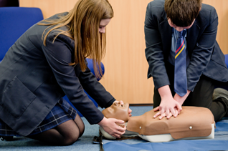
Why will I enjoy Health and Social Care?
Health and social care is a stimulating and thrilling sector of employment within the United Kingdom especially in Herefordshire. The course prepares students who want to pursue a career in health and social care, and /or take higher qualifications in the subject. As well as learning about the world of health and social care, you will be able to take part in practical tasks. We will do teambuilding activities to help you challenge yourself and develop the skills you will need in the workplace.

What abilities may help me in Health and Social Care?
Resilience is essential. The course is demanding with a large amount of research and written work to complete.
We deal with sensitive topics, so a respect for others is essential.
Empathy is vital if you are going to be able to understand the needs of others.
Teamwork and leadership to help the group achieve together.
A passion for caring about others.
Bravery when dealing with blood and bodily fluids.

What will I learn in Health and Social Care?
The Award gives learners the opportunity to develop sector-specific knowledge and skills.
The main focus is on four areas of equal importance, which cover the:
• Development of key skills that prove your aptitude in health and social care such as interpreting data to assess an individual’s health
• Process that underpins effective ways of working in health and social care, such as designing a plan to improve an individual’s health and wellbeing
• Attitudes that are considered most important in health and social care, including the care values that are vitally important in the sector, and the opportunity to practise applying them
• Knowledge that underpins effective use of skills, process and attitudes in the sector such as human growth and development, health and social care services, and factors affecting people’s health and wellbeing.

How will I get marks in Health and Social Care?
You will complete two pieces of coursework which make up 60% of your overall final grade. The first piece of coursework is due in at the end of the first term. The second piece is due in at the end of the second term. Your teacher will mark these, which will give you an idea of how you are getting on. Towards the end of the course you will do an exam, where you use the knowledge, skills and techniques you have learned. All the work you do throughout the course prepares you for this exam which is marked externally.

What is the structure of the course?
The course is made up of three components: two internally assessed and one that’s externally assessed. The three-block structure, explore, develop and apply, has been developed to allow students to build on and embed their knowledge.

If I take Health and Social Care what can I do with it as a career in the future?

When you have completed this qualification, you will have developed a practical understanding of the health and social care sector. Because you will be building useful skills not generally covered in GCSE courses, you will have a better understanding of whether this is an area you want to continue to study. This course will also help you develop transferable skills and knowledge, such as self-evaluation and research skills, which will benefit you wherever you progress to next.
The course is suitable for students wishing to pursue a career in medical professions like Nursing, Midwifery and Social work, It will also help students who wish to work in education.

How can I find out more?
Further information about this qualification can also be accessed at:
https://www.ocr.org.uk/Images/610950-specification-cambridge-nationals-health-and-social-care-j835.pdf

Curriculum Team Leader: Mrs L Barker
ASDAN Overview – INVITE ONLY

Land-Based Studies - (Non-GCSE Qualification)
Qualification Type: Entry Level / Level 1 Award
Who is it for? Students who would benefit from a practical, hands-on learning route and who enjoy working outdoors and completing structured tasks in a calm, purposeful environment.
Course Overview
This new KS4 SEN pathway offers a highly practical, land-based curriculum designed to help students develop real-world skills. The course is taught in small groups with a high level of support and a strong focus on building confidence, independence, and teamwork.
This course contains six modules, corresponding to different aspects
of the land-based sector:
- Agriculture
- Animal care
- Horticulture
- Environment and land management
- Health and safety in the land-based sector
- Careers in the land-based sector

How is the course assessed?
Assessment is based on coursework and practical tasks. There are no written exams. Students build a portfolio of evidence showcasing their skills, progress and completed projects.
What can this lead to?
- Further land-based qualifications at college (e.g., Horticulture, Agriculture, Animal Care)
- Supported internships or vocational pathways related to outdoor work
- Skills and routines that support independence and future employability

Why choose this course?
This pathway is ideal for students who learn best through doing rather than extended writing, and who benefit from a structured, nurturing learning environment. It gives them the chance to shine in a practical subject area while developing important life and work skills.
Arts Award Overview – INVITE ONLY
Arts Award Bronze is a nationally recognised qualification that encourages young people to explore the arts.
Students develop their creative skills by taking part in arts activities and learning about artists and organisations.
The course builds confidence, teamwork, and communication through practical projects and reflection.
It is ideal for students who enjoy creativity and want to gain a valuable qualification alongside GCSEs.

Springboard Overview – INVITE ONLY
Students invited to do the Springboard Option will do one less GCSE Option. In the 5 hours of Springboard they will have opportunities to study extra English and Maths with a specialist teacher and time in a computer room where they can have time and support with NEA (coursework), revision and other independent study.

- Students may be selected to have the ASDAN, Arts award and Springboard Option.
- Mr Vaughan or Mrs Collingbourne will discuss these options with the selected students and the parents / carers.

Year 9 students: Starting year 10 Options
All students will do English Literature, English Language, Maths, Combined Science, Core PE, and Religious Studies (short course) so they will not feature in the options list.

Instructions for the option choices:

Using the Student Sims app, students must choose 4 options in order of preference and a reserve

Option A – favourite subject
Option B – second favourite
Option C – third favourite
Option D – fourth favourite
Reserve Option – fifth favourite

Students MUST select at least one from: Geography, History, Computer Science or a Language as part of their 4 choices.

Careers Education, Information and Guidance


Careers work is further developed in Key Stage 4 where students have a clearer understanding of who they are and how their self-esteem affects what they do. They engage in an understanding of the world of employment through the Year 10 Work Experience programme, by spending a few days in industry which includes an in-school focus on interview skills, employers’ expectations, confidence building, health and safety and team work.

We work closely with the Education Business Partnership to help the students choose the right pathway for them.

During Year 11, Mrs Williams interviews all students to discuss their options for Post 16, and provide information and guidance on Modern Apprenticeships, Sixth Form entries.
College and other training pathways. Tutors and staff are encouraged to talk about these routes with students, especially after an interview so that the students can research further options themselves.

Mrs Williams is also available to give advice to both students and parents during this options process.

Some questions to think about:

What do I want to be when I leave school?
You may already know exactly what career you wish to follow. If so, you should choose subjects which may be needed as qualification. Your form tutor will be able to help guide you about whether this is suitable for you.

You may change your mind about your career over the next three years and it is not possible to change your choices mid-way through a two year course. You may wish to consider what you would like to study post Year 11 or what training you may want to pursue after school.


You may have no idea what you want to do when you leave school. You should choose a balanced range of courses from those available. This will leave you with plenty of options and possible careers to pursue.

What subjects do I enjoy?
Only you know the answer to this. If you like a subject you will not mind working hard at it. Hard work is essential no matter what you choose.

What subjects am I good at?
As well as thinking carefully about this yourself, you should use the advice of your teachers and Form Tutor. Consultation evening will help with this.

How do I enjoy working?
Some of the subjects will require you to do some Non-Examined Assessment (NEA); others are assessed mainly by exam. Think about which way of working you prefer.

Dates | Event
End of January | Introduction to Options by Form tutors
5th February 2026 | Options Evening
19th March 2026 | Year 9 Virtual Consultation Evening
20th March 2026 | Option form opens on Sims Student App
27th March 2026 | DEADLINE for Option choices to be completed online
April | Options 1 – 1 meeting with SLT and HOH
June 2026 | Student’s choices confirmed

Your Notes

