Bishop of Hereford’s Bluecoat School

UNIFORM Guidance and expectations – September 2026
General Uniform
- BHBS Blazer (branded item 1) - are compulsory and should be worn at all times in the building unless a member of staff gives permission for them to be removed.
- Jumper (non-branded) - Jumper – Navy blue
  - A navy blue v neck jumper may be worn under a blazer, the jumper must not have buttons or emblems of any type.
  - Jumpers are an optional item and are not a replacement for the blazer.
- BHBS Tie (branded item 2) – are compulsory and only one shirt button should be seen below the tie. This creates a consistent and appropriate length.
- Shoes (non-branded) - Black (no colour visible on the outside including the sole), smart, safe and sensible (with a heel not exceeding 2 inches).
  - Shoes should be polishable
  - Trainers and canvas shoes are not allowed.
  - There should be no obvious sports brands identified on the outside of the shoe.
  - Boots are not acceptable.
- Shirt (non-branded) - Pale blue
  - Tucked in all the way round on the waist
  - Top buttons are to be used at all times, so please make sure that the neck size is appropriate.
  - The shirt can be long or short sleeved in length.
  - No brands or logos are permitted
  - Shirts are not permitted to be button down collar

- BHBS Skirt (branded item 3 – if worn) - Regulation tartan school skirt
  - All skirts have a minimum length of 20”, in exceptional circumstances only the school will authorise and sell, an 18” skirt – alternatives are not acceptable
  - Skirts must not be rolled up.
  - The bottom (hem) of the skirt must be as close to the top of the knee as possible.
  - Adjustments to the length/style of the skirt are not permitted
- Trousers (non-branded) - Black straight cut.
  - Casual or drainpipe style trousers are not acceptable this includes jeans, cords, legging style and denims.
- BHBS Tailored unisex shorts (branded item 3 – if worn) – blue - are also available from the school shop which have the school initials.
  - No other designs are acceptable.
  - Please note we have limited sizes.
- Socks (non-branded) - black socks (ankle or knee length).
  - No coloured patterns and motif/logos visible when shoes are worn.
- Tights (non-branded) - plain black and they must have no rips or holes.
  - Plain black socks may be worn underneath the tights.
- Warm waterproof coats (non-branded) - should be worn to and from school.
  - They can be worn in the building but must be removed when entering a classroom and placed over the chair.
- Hoodies are not permitted to be worn on the school site.

Should a student arrive at school incorrectly dressed every effort will be made to solve the issue, failure to accept the support may result in normal school sanctions being applied.
The School’s decision on all queries is final.

Exams and Uniform
Full school uniform is expected in all school exams. Failure to attend appropriately attired could result in not being able to complete the exam

Hair
- Hair should be neat, tidy and of natural colour and in a non-extreme style.
- The school reserves the right to judge what is considered natural or extreme.
- There should be no obvious evidence of colouring of any kind
- Students with long hair should tie it back during particular lessons for safety reasons.
- All beards should be trimmed and neat in appearance.
- Hair will be cut no shorter than a grade four on the top of the head. Patterns or lines are not acceptable in the hair or eyebrows.
- If you are in any doubt please contact the school before any new style is introduced.

Jewellery
- One small pair of gold or silver stud earrings can be worn in the lower lobe of either ear, but no more than one earring in an ear.
  - Hoops style earrings are not acceptable
  - Studs must not have patterns, colours or designs
- Rings, bracelets and necklaces are not allowed.
- Facial or body piercings are not allowed.
  - Any other forms of jewellery must not be worn.
- Only badges and flashes provided by the school can be worn on the blazer, with the exception of poppies for Remembrance.

Make-Up and Cosmetics
- Staff should not be able to see the use of make-up. If make-up can be seen it means it is not discreet enough for our school environment.
- Nails should be natural in colour with no nail varnish.
- False nails or acrylics are not allowed, there are no exceptions to this.
- False eyelashes/extensions/eye liner are not allowed.

Should a student arrive at school incorrectly dressed every effort will be made to solve the issue, failure to accept the support may result in normal school sanctions being applied.
The School’s decision on all queries is final.

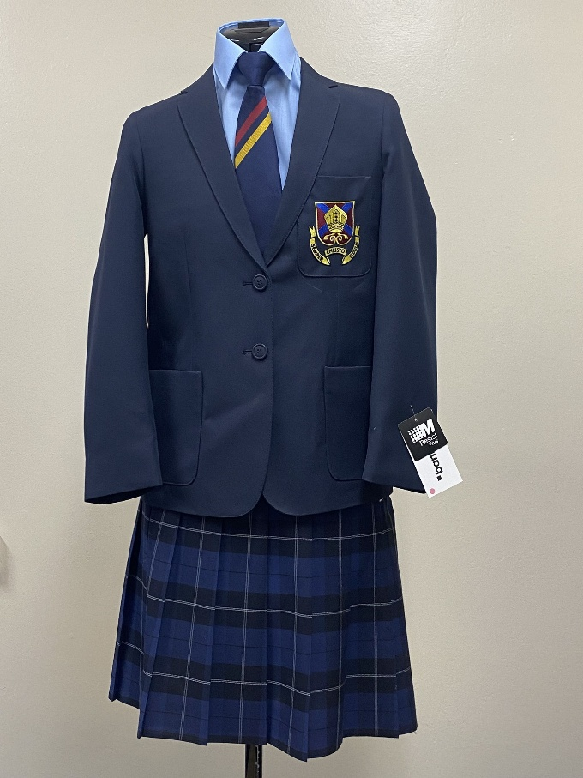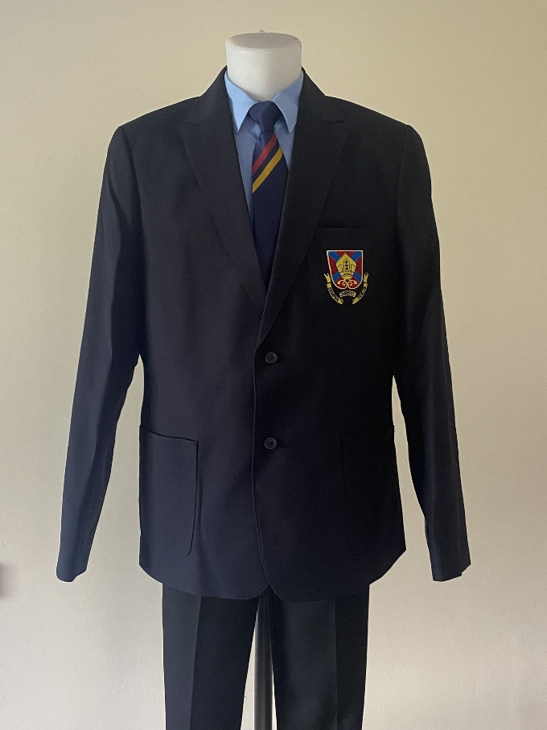
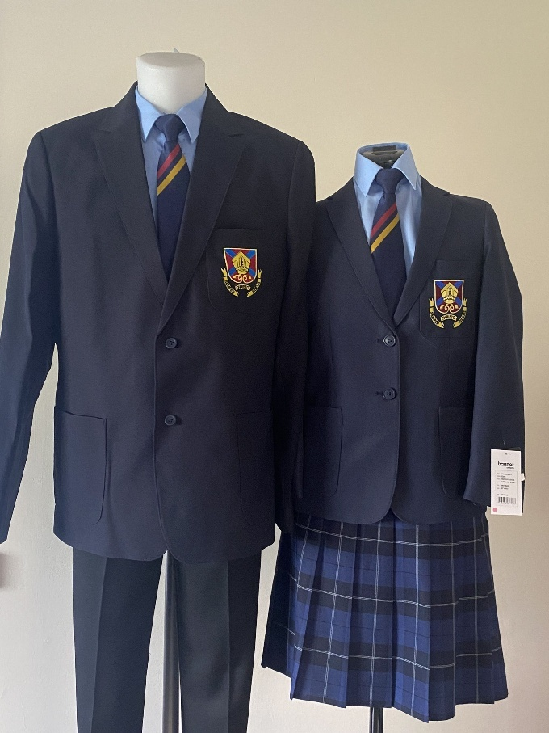

Physical Education (PE) Kit Policy

This guidance outlines the compulsory PE kit requirements for all students at The Bishop of Hereford’s Bluecoat School (BHBS). The PE curriculum includes a wide range of physical activities, therefore all students, regardless of gender, are required to wear the same standard kit to ensure safety, comfort, and consistency.

All items specified in this policy are available for purchase from Club Sport or other retailers (apart from the branded items).

Students are expected to wear the correct PE kit for all lessons even when they are ill or injured. Lessons are often outside or on the field. Where students are physically able to get changed, they are expected to do so. There are many roles that ill or injured students can complete in a lesson such as coaching or officiating. We do not want students to get uniform/shoes muddy or wet. If PE kit uniform is not brought into school for a PE lesson , sanctions will be issued in line with the school behaviour policy.

All students with hair long enough to be tied back will be asked to do so.

All jewellery will be removed for health and safety reasons.

All unbranded items are to be of similar colour Navy to the branded PE top and school blazer.

All belongings, including clothing and footwear, should be clearly named to facilitate swift return if items are lost. Any lost property will be taken to Student Services and if unclaimed after a period of time, will be disposed of or offered for re-sale.

Please see the link below to Club Sport:

The Bishop of Hereford Bluecoat School

Compulsory PE Kit

BHBS PE Top (Branded Item 4)
Students must wear one of the following BHBS-branded options:
- BHBS Slim-Fit V-neck Polo
- BHBS Unisex Polo

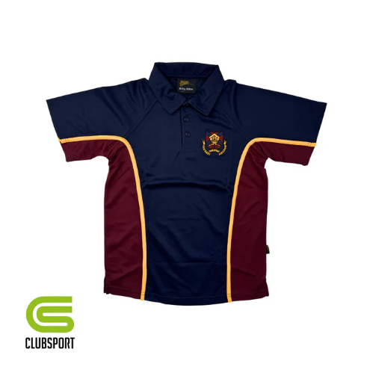OR | 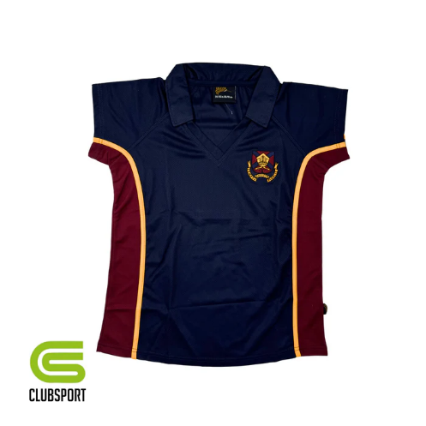
Both items are currently £16 in club sport

Base layer (s) (optional)
Students can wear a navy short sleeved top underneath their BHBS top to keep warm. If the item is long sleeved it must be tight fitting.

Sports Bra
- If required for support

Bottoms (one only required from the options available – can be purchased at club sport or alternative retailers).

Shorts
- Plain Navy classic straight cut mid-thigh shorts.
- No lycra material

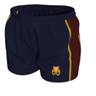
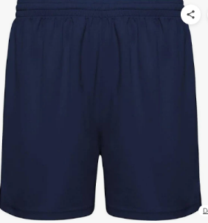

OR

£12 from club sport OR available at other retailers.

Tracksuit Bottoms
- Plain Navy
- No stripes
- No poppers
- No zips (Health and Safety considerations)
- Full length only

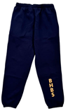 OR 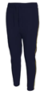

£18 at Club Sport, or available at other retailers.

Leggings
· Plain dark navy
· No stripes
· Full length only
· No holes, gaps, or decorative meshing
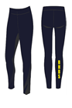
OR

£20 in Club Sport, or available at other retailers.

Socks
Black socks (ankle or knee length).
- To be worn for indoor and summer sports

Long Navy Football or Rugby Socks
- Required for football and rugby lessons for all students regardless of gender.
- Must be plain
Note: All students—boys and girls—will take part in football and rugby as part of the curriculum.

Students can opt to wear BHBS socks if they have already purchased them.
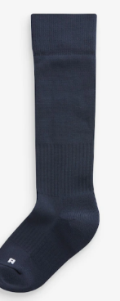
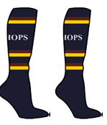
OR

Available from other retailers.

Additional Compulsory Equipment
The following items are required for safety during practical activities:
- Gumshield
- Shin pads
- Football/rugby boots
- PE trainers
- Hair tie

All items listed above are available from Club Sport or other retailers.

Whilst stocks last the following optional items are also available to be purchased (and can be worn if already purchased). As stocks diminish these will be replaced with base layers.

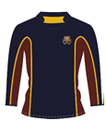Long sleeved rugby top. £33 or £39
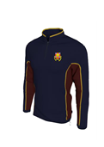1/4 zip fleece £21 or £27

Skorts
Skorts can be worn by students in years A, B, Z & Y during the academic year 2026/27.
From September 2027 students will be unable to purchase skorts
From September 2027 skorts will no longer be acceptable PE kit, students will need to wear shorts, tracksuit bottoms or leggings as mentioned above.

