
The Bishop of Hereford’s Bluecoat School

Admissions Policy 2027/2028
SLT Lead: Jonathan Nicholas
Reviewed by SLT: September 2026
Governor Committee Approval: September 2026
Review Date: September 2027

The school’s vision
Jesus said: “I have come that they may have life, life in all its fullness.” This serves as the cornerstone of our school community. By fostering a culture of positive learning experiences rooted in core Christian values, we aim to equip our students for a life of resilience, fulfilment, and meaningful contribution to society.
This policy supports our school vision and ethos.

Contents Page
- Introduction 2
- Process 2
- Oversubscription Criteria 3
- In-Year Admissions 5
- Students who move to Herefordshire 5
- Students who move into catchment area 5
- Students who reside outside of catchment area 6
- Admission of children outside of their age group 6
- Waiting lists 7
- Appeals Procedure 7
- Address Definition 8
- Enquiries 8

Introduction
This document sets out the admission arrangements of The Bishop of Hereford's Bluecoat School. For the purposes of this policy, the Governing Body is the admission authority.
Everyone is welcome at Bishops. Through our Christian identity, we aim to realise every learner's God-given potential by:
• Providing a nurturing, happy environment where each student is safe, respected as an individual and makes a positive contribution to the wellbeing of others.
• Inspiring a delight in learning every day so that students achieve their best, academically, socially and are encouraged to further their enjoyment by participating in extracurricular opportunities.
• Instilling life-long learning skills, each to be proud of their identity, aiming high with their ambitions, yet content with who they are.
• Living and breathing our core Christian values to create a caring community that is inclusive and closes the gap of inequalities.
• Encouraging all students to take responsibility for their learning and talk confidently with their peers and staff about their learning journey.
• Supporting students in recognising that making mistakes is an important part of learning and becoming resilient.
• Developing a hunger to discover, a thirst for wisdom and grace to grow. Bishops students chose the following seven core Christian values.

These values link to all the work we do here at Bishop's:

Equality, Kindness, Trust, Love, Honesty, Peace, Forgiveness

Process
- Applications for admission to the school should be made using the Local Authority Common Application Form by the national closing date of 31st October.
- The Local Authority will inform parents of the offer of a place on behalf of the Governing Body on the national offer date 1st March or next working day.
- The Bishop of Hereford's Bluecoat School has an admission number of 220 pupils for entry into Year 7. The school will accordingly admit at least 220 each year if sufficient applications are received. All applicants will be admitted if 220 or fewer apply. The school will admit any pupils with an Education, Health and Care plan naming the school. Priority will then be given to those children who meet the criteria set out below.

Oversubscription Criteria

(1)Looked After Children, Previously Looked After Children and Internationally Adopted Looked After Children (LAC, PLAC and IAPLAC)
The first oversubscription criterion must always be Looked After, Previously Looked After and Internationally Adopted Previously Looked After Children. As this is a legal requirement, it automatically appears as the first of the school's oversubscription criteria.
A “Looked After Child” (LAC) s a child who is (a) in the care of a local authority, or (b) being provided with accommodation by a local authority in the exercise of their social services functions (see the definition in Section 22(1) of the Children Act 1989) at the time of making an application to a school.
A "Previously Looked After Child" (PLAC) is a child who was looked after but ceased to be so because they were adopted or became subject to a child arrangement order or special guardianship order immediately following having been looked after.
An "Internationally Adopted Previously Looked After Child (IAPLAC) is a child who appears (to the admission authority) to have been in state care outside of England and ceased to be in state care as a result of being adopted.

(2)Catchment area

Children living in the catchment area of the school:

The area includes Tupsley, south of the Ledbury Road and east of the Eign Brook (the centre of the road and the brook being the boundary), the designated civil parishes of Hampton Bishop, Mordiford, Fownhope, Woolhope, Lugwardine, Bartestree and Dormington.
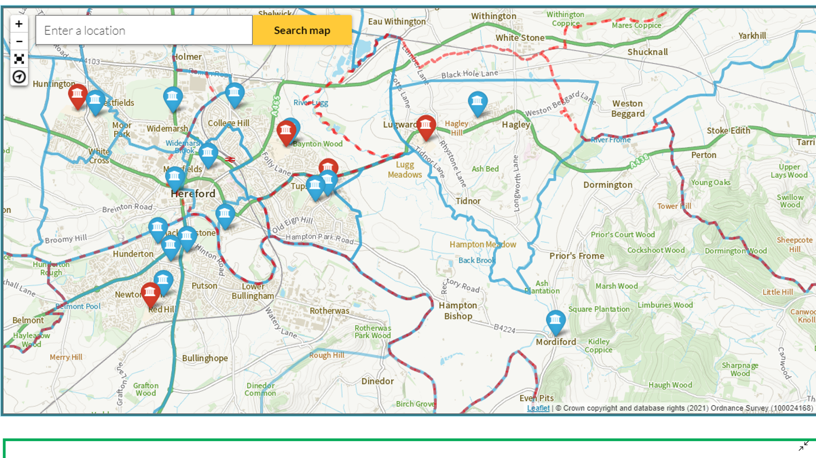

A more detailed map can be viewed by following this link and selecting the Bishop of Hereford’s Bluecoat School:
https://www.herefordshire.gov.uk/schools-education/schools-catchment-map

(3) Siblings
Siblings of pupils attending the school during the academic year to which the child would be admitted. ‘Sibling’ means a natural brother or sister, a half brother or sister, a legally adopted brother or sister or half-brother or sister, a step brother or sister, or other child living in the same household who, in any of these cases, will be living with them at the same address at the date of their entry to the school.

(4) Named Feeder School
Children attending St. Paul's, Hampton Dene, St. Mary's Fownhope, Mordiford or Lugwardine at the time of the closing date for application.

(5) Social and Medical need
Priority will be given in exceptional circumstances to a small number of children (or in some cases a close relative of the child) whose mental or physical impairment means they have a demonstrable and significant need to attend this school over any other.
Supporting evidence in the form of a letter from a doctor or social worker or other relevant qualified, independent professional, would be required. Medical, health, social and special access reasons will be applied in accordance with the school’s legal obligations and does not guarantee that a child will be given priority as each decision will be made on the merits of the individual case.

(6).Distance from school
Proximity to the school with those living closest to the school having priority calculated by:
Distance is measured by the shortest available walking route (using road and/or made up footpath) using the nearest network node from the property address point to the nearest network node at the main school entrance gate
The child’s home address will be determined by:
This is the home, where the child is normally resident.
Proximity to the school is measured by the shortest walking distance by road or maintained footpath or other public rights of way from the pupil’s home, to the main entrance point of the school using a GIS computerised mapping system.
In the event that two or more children live at the same distance from the school (as can happen with families living in blocks of flats), random allocation, where supervised drawing of lots by an independent responsible person of good standing will be used to decide which child(ren) will be allocated the remaining place(s) (in accordance with 1.34 and 1.35 of the School Admissions Code).

(7)Late applications
Applications received after the closing date and before the Herefordshire County Council admission meeting will be placed last in the criteria in which they fall unless Herefordshire County Council is satisfied that there are exceptional circumstances which reasonably prevented the application from being submitted on time. Supporting evidence must also be supplied by the closing date for applications, unless it is satisfied that there are exceptional circumstances which reasonably prevented it being submitted on time. In the absence of such supporting evidence, the allocation of places will be made on the basis of the application alone.

In-Year admissions outside the normal transition period
The allocation of places is in accordance with the admissions criteria. Preference will be given to children moving into the area from outside the Local Authority area who do not have a school place. Evidence will need to be provided that the child has recently moved in.
In all cases an ‘In Year Transfer Application Form’ will be completed. This form will be copied to the Local Authority and BHBS will notify the LA and parents/carers of the outcome.

- Students who move to Herefordshire
Students who move into Herefordshire can apply direct to BHBS and a place will usually be granted, providing that we are not above PAN (pupil admission number) in that year group. If we are above PAN , then we will have to consider whether the arrival of an additional student could have a detrimental effect on other students. The family will be invited to an informal meeting and a tour of the school, which must take place before an offer is made. This is for parents/carers to ensure that BHBS is the right place for the student. If we are below PAN, then the student would normally be accepted, unless there are concerns over the impact the student may have on the year group and school. For students that have complex behaviour issues a referral to ‘In-Year Fair Access’ may be made if they are considered a ‘hard to place’ student.

- Students who already go to a school in Herefordshire, who then move into our catchment
Any student who wishes to move from a school within Herefordshire must complete an ‘In year Transfer Application Form’. If a student moves into the catchment of BHBS and there is capacity, then the student would normally be accepted into BHBS, providing the current school is supportive of the move. The family would normally meet with the Deputy Headteacher responsible for admissions. Where there have been issues of poor behaviour or low attendance, then BHBS may refer the application to the ‘In-Year Fair Access Panel’. The school may also seek to arrange a managed move, to provide an opportunity for the student, parents/carers and BHBS to make sure this is the right place. A transfer to BHBS will not normally be supported when a student is in year 11, because a move at this stage can be very disruptive for the young person. Year 10 students may be allowed to transfer in the autumn term, providing that courses match up and the student can demonstrate a willingness to catch up on any missed work.
- Students who already go to a school in Herefordshire, but reside outside our catchment
A transfer will not automatically be granted, when a student wishes to transfer to BHBS, yet resides outside our catchment. An ‘In-year transfer Application Form’, must be submitted and the student and parent/carer must meet with the Deputy Headteacher, responsible for admissions. Where there have been issues of poor behaviour or low attendance, then BHBS may refer the application to the ‘In-Year Fair Access Panel’. Moving school can be a disruptive and challenging experience, so the school and family must be satisfied that the move is appropriate. Reasons for moving may include the following:
- Current school unable to offer a particular curriculum pathway
- Evidence of persistent bullying at current school
- Sibling is attending BHBS
- Student has felt isolated at current school and has been unable to settle;
- If current life at school is leading to mental health issues verified through CAMHS or a Doctors letter.
- Student genuinely wishes to make a fresh start and this is supported via the ‘managed move protocols’
- The In Year Fair Access Panel has decided that the student should come to BHBS

If the current school is failing to make appropriate provision within the terms of the special needs code of practice 2014, then this should not be a reason to move to Bishop’s.
The Deputy Headteacher will liaise with the Headteacher about all transfers and will provide detail about why they think the application should be supported or turned down. The final decision lies with the Headteacher.

Admission of children outside their normal age group
Parents may request that their child is admitted to a year group outside their normal age range, for instance where the child is gifted or talented or where a child has suffered from particular social or medical issues impacting on their schooling. All such requests will be considered on their merits and either agreed or refused, on that basis. If a request is refused, the child will still be considered for admission to their normal age group.
The process for requesting such an admission is as follows: With the application, parents should request that the child is admitted to another year group (state which one), and the reasons for that request. Parents will submit any evidence in support of their case with the application, for instance from a medical practitioner, headteacher etc. Some of the evidence a parent might submit could include:
- information about the child’s academic, social and emotional, development
- where relevant, their medical history and the views of a medical professional
- whether they have previously been educated out of their normal age group
- whether they may naturally have fallen into a lower age group if it were not for being born prematurely.
The school will consider each case on its merits, taking into account the individual circumstances of the request and the child’s best interests. We will also ensure the parent is aware of whether the request for admission out of age group has been agreed before final offers are made, and the reason for any refusal. Requests for admission out of the normal year group will be considered alongside other applications made at the same time. An application from a child who would ‘normally’ be a year 8 child for a year 7 place will be considered alongside applications for year 7.

- Waiting Lists
The school will operate a waiting list for each year group. Where in any year the school receives more applications for places in year 7, than there are places available, a waiting list will operate until the end of the first term after the beginning of the school year. This will be maintained by the admission authority and it will be open to any parent to ask for their child’s name to be placed on the waiting list, following an unsuccessful application. Children’s position on the waiting list will be determined solely in accordance with the oversubscription criteria. Where places become vacant they will be allocated to children on the waiting list in accordance with the oversubscription criteria. The waiting list will be reordered in accordance with the oversubscription criteria whenever anyone is added to or leaves it.

Appeals Procedure
All applicants refused a place have a right of appeal to an independent appeal panel constituted and operated in accordance with the school admission appeals code. Anyone who makes an appeal will be referred to as the appellant for the purposes of this document.
Appellants for transition into the September of year 7 should contact Jonathan Nicholas at The Bishop of Hereford's Bluecoat School within 20 school days of the date of the letter refusing your child a place. For appeals about in-year admissions, appellants should contact Pete Gibbins at The Bishop of Hereford's Bluecoat School within 20 school days of the date of the letter refusing your child a place
If you submit your appeal after the deadline, it might not be considered and may result in a delay to your hearing.
You will be provided with at least 10 school days’ notice of the hearing and we will endeavour to hear the appeals within 40 school days of the deadline for making an appeal. For applications for in-year admissions, appeals must be heard within 30 school days of the appeal being lodged.

What happens at the appeal hearing:

A panel of 3 or more independent people and a clerk will be at the appeal hearing. The panel will follow the school admission appeals code.
- Bishop’s school will explain why the application was turned down
- You’ll be able to give your own reasons why your child should be admitted.
- The appeals panel must decide if the school’s admission criteria were properly followed and comply with the school admissions code.
- If the criteria were not properly followed or do not comply with the school admissions code your appeal will be upheld.
- If your reasons for your child to be admitted outweigh the school’s reasons for not admitting any more children at all, your appeal will be upheld.
- You will usually be sent the decision within 5 school days.

Address definition
The address is the place where the child is permanently resident with his or her parent or parents or legal guardians. Evidence may be requested to show the address, for example: to which any Child Benefit is paid or at which the child is registered with a medical GP together with recent utilities bill, council tax bill or tenancy agreement. This evidence will be used when reaching a decision on the child's home address for admissions purposes (including where a child lives with parents with shared responsibility for each part of the week). Parents should not assume that a place will automatically be allocated to their child.

Enquiries
Year 6 to year 7 transition questions should be directed to Jonathan Nicholas at BHBS, Hampton Dene Road, Tupsley, Hereford, Herefordshire, HR1 1UU. jnicholas@bhbs.hereford.sch.uk.
All other queries and applications should be directed to Pete Gibbins at the same address pgibbins@bhbs.hereferd.sch.uk

Approved by the Vision & Ethos Committee on the 2nd of October 2025

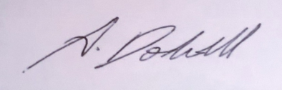

…………………………………………………….
Chairman

